**VIET NAM NATIONAL UNIVERSITY HO CHI MINH CITY**

**UNIVERSITY OF INFORMATION TECHNOLOGY**

**INFORMATION SYSTEM FACULTY**



**LAB 1 REPORT**

**BUSINESS ANALYSIS**

Instructor: Nguyen Thi Viet Huong

Student performance: Team 15

Nguyen Cam Tu 20520837

Nguyen Thi Thu Thuy 20520797

Nguyen Thanh Son 20521847

**HO CHI MINH CITY, MARCH 2023**

# TEACHER’S COMMENT

# TABLE OF CONTENT

TEACHER’S COMMENT 2

TABLE OF CONTENT 3

JOB DISTRIBUTION 5

A. GDP of Vietnam 6

1. Using MS Excel, R, and Python Programming Language 6

1.1 Using MS Excel 6

1.2 Using R Programming Language 16

1.3 Using Python Programming Language 18

2. Data Visualization 21

1.1 Using MS Excel 21

1.2 Using R Programming Language 23

1.3 Using Python Programming Language 24

B. Purchase Orders 26

1. Using MS Excel, R and Python Programming Language 26

1.1 Using MS Excel 26

1.2 Using R Programming Language 36

1.3 Using Python Programming Language 38

2. Data Visualization 41

1.1 Using MS Excel 41

1.2 Using R Programming Language 42

1.3 Using Python Programming Language 44

C. Computer Repair Times 45

1. Using MS Excel, R and Python Programming Language 45

1.1 Using MS Excel 45

1.2 Using R Programming Language 55

1.3 Using Python Programming Language 57

2. Data Visualization 60

1.1 Using MS Excel 60

1.2 Using R Programming Language 60

1.3 Using Python Programming Language 63

D. REFERENCES 65

# JOB DISTRIBUTION

|  |  |  |  |
| --- | --- | --- | --- |
| **Member**  **Work** | **Nguyen Cam Tu (Leader)** | **Nguyen Thi Thu Thuy** | **Nguyen Thanh Son** |
| Problem statement | ✓ | ✓ | ✓ |
| Build a report template | ✓ | ✓ | ✓ |
| Learn to use Excel, R, Python | ✓ | ✓ | ✓ |
| Do Exercise A (Excel) |  | ✓ |  |
| Do Exercise A (R) |  |  | ✓ |
| Do Exercise A (Python) | ✓ |  |  |
| Do Exercise B (Excel) | ✓ |  |  |
| Do Exercise B (R) |  | ✓ |  |
| Do Exercise B (Python) |  |  | ✓ |
| Do Exercise C (Excel) |  |  | ✓ |
| Do Exercise C (R) | ✓ |  |  |
| Do Exercise C (Python) |  | ✓ |  |
| Summarize and edit reports | ✓ |  |  |
| Completion (%) | 90% | 90% | 90% |

**LAB 1**

1. ***Data Visualization and Descriptive Statistics:***

* Using MS Excel, R Programming Language, and Python Programming Language; calculate and analyze the meaning of the values: Count, Min, Max, Mean, Median, Mode, Quantile, Range, Variance, Standard Deviation, Coefficient of Deviation, Skewness, Kurtosis.
* Using Visualization: Histogram, Box Plot to visualize some of the above values.

1. ***Practice on 3 datasets:***
2. GDP of Vietnam *(http://finance.vietstock.vn/du-lieu-vi-mo/Default.htm)*
3. Purchase Orders
4. Computer Repair Times

# GDP of Vietnam

## Using MS Excel, R, and Python Programming Language

### Using MS Excel

#### Statistical description

**Step 1:** Choose the “Dữ liệu” tab on the top of the Excel toolbar. Click the “Data Analysis” function. Click “Descriptive Statistics,” and the “OK” button in the window that pops up.

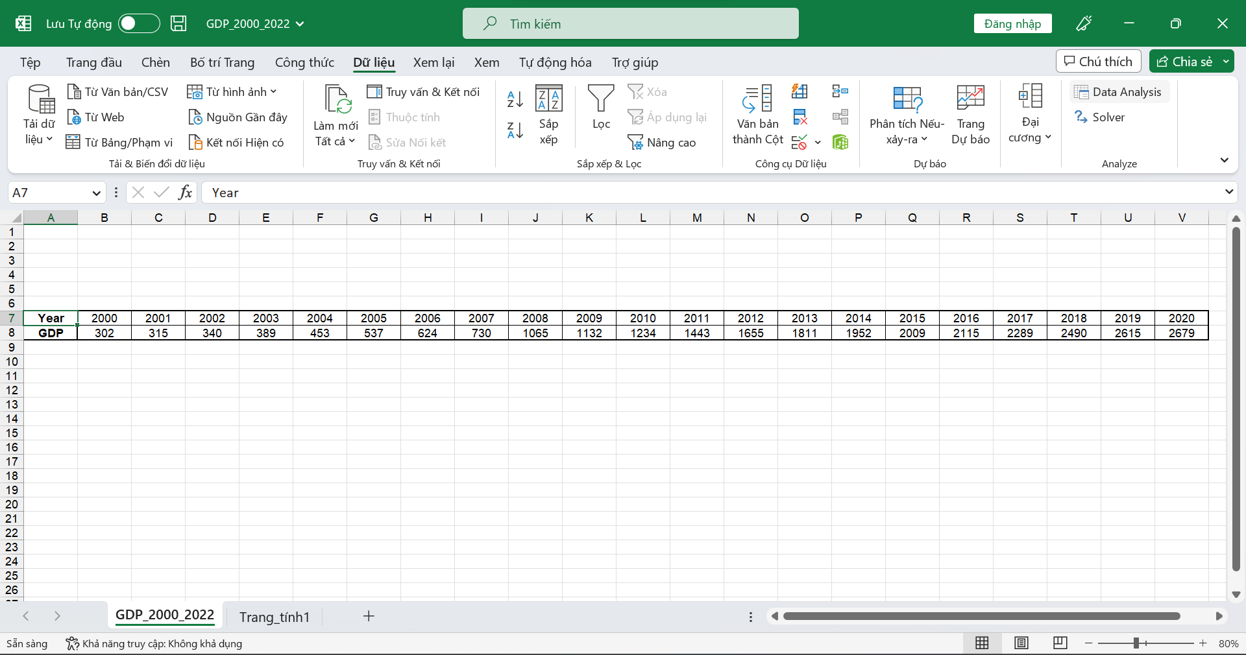

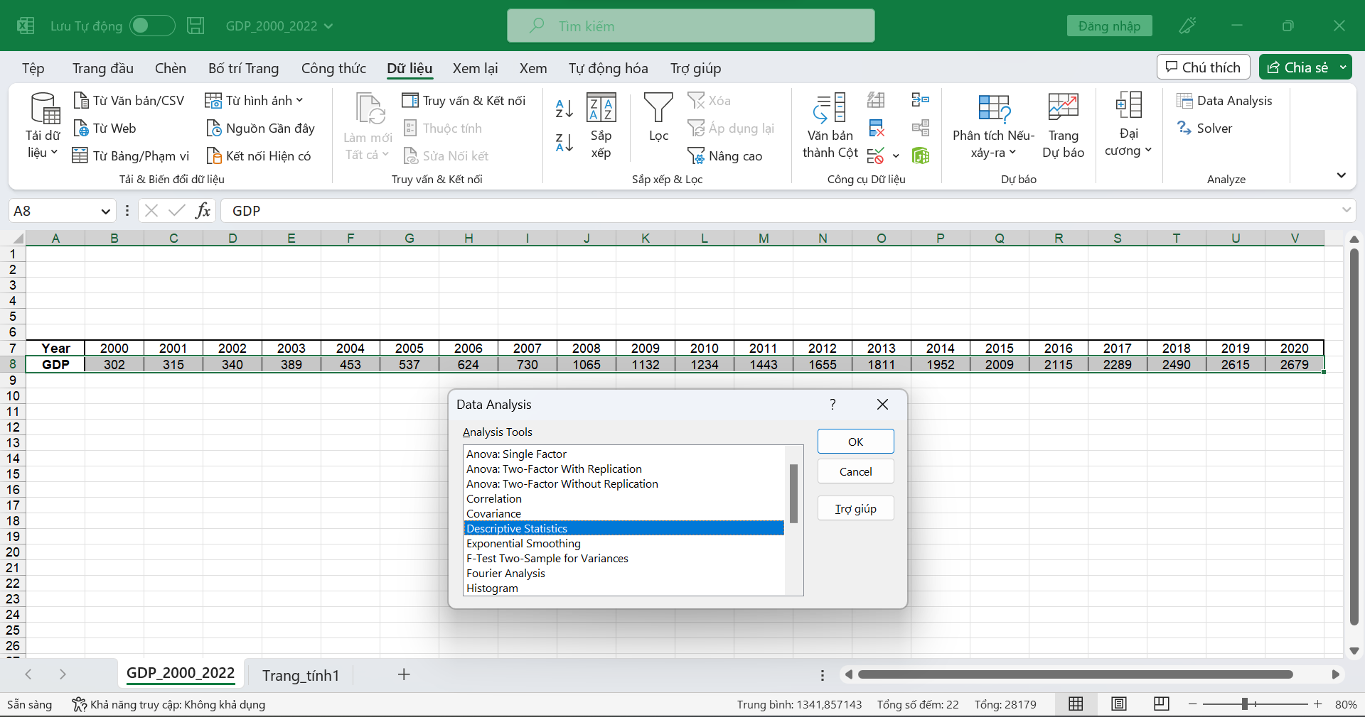

**Step 2:** Enter Input Range and select “Rows” on the “Grouped By:” function.

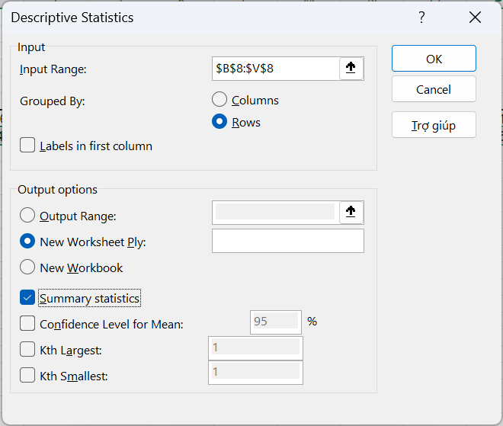

**Step 3:** Get the final result

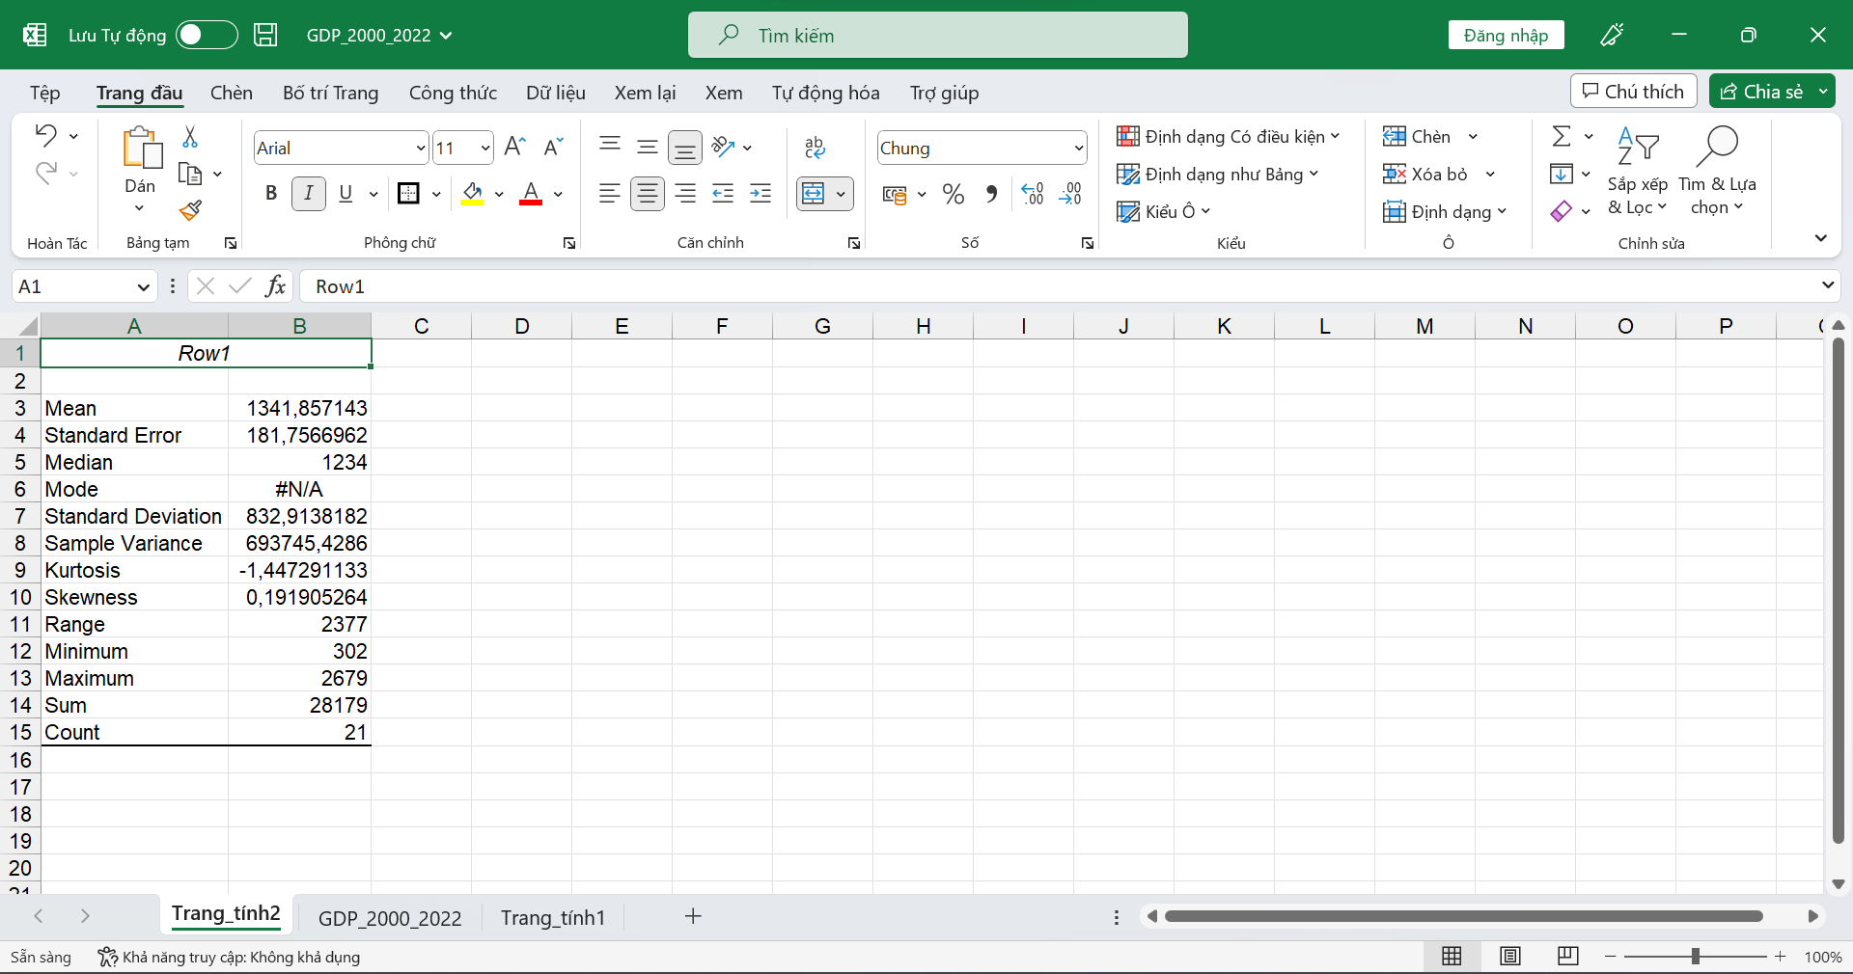

#### Meaning of values

The meaning of the values: Count, Min, Max, Mean, Median, Mode, Quantile, Range, Mode, Variance, Standard Deviation, Coefficient of Deviation, Skewness, Kurtosis.

**Count:** Count how many numbers are in the list of arguments

**Min:** Returns the minimum value in the list of arguments

**Max:** Returns the maximum value in the list of arguments

**Mean:** the arithmetic means of a variable, calculated as the sum of the observations divided by the number of words. AVERAGE (data range)

**Median:** Returns the median of the given numbers

**Quantile:** Returns the quartile of the data set. The **quartiles**of an ordered data set are the 3 points that split the data set into 4 equal groups. The **quartiles**are defined as follows:

* **Q1** : The **first**quartile is the middle number between the *smallest*number in a data set and its *median*.
* **Q2** : The **second**quartile is the median (50th percentile) of the data set.
* **Q3**: The **third**quartile is the middle number between a data set’s *median*and its *largest*number.

The value Q3 – Q1 called the **Interquartile Range**.

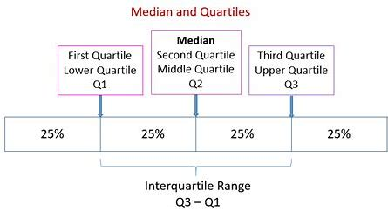

**Mode**: Measures central tendency, which is the central position of a group of numbers in a statistical distribution. The three most commonly used measures of central tendency are: The mean is the arithmetic mean, calculated by adding a group of numbers and then dividing by the number of numbers.

**Variance:** Estimates of variance based on samples

**Standard Deviation:** Estimate the standard deviation based on the sample. The standard deviation is a measure of the dispersion of the values from the mean (the mean).

**Skewness:** Returns the skewness of the distribution

**Kurtosis:** Returns the convexity of the data set

#### Recalculation using Excel

**COUNT**

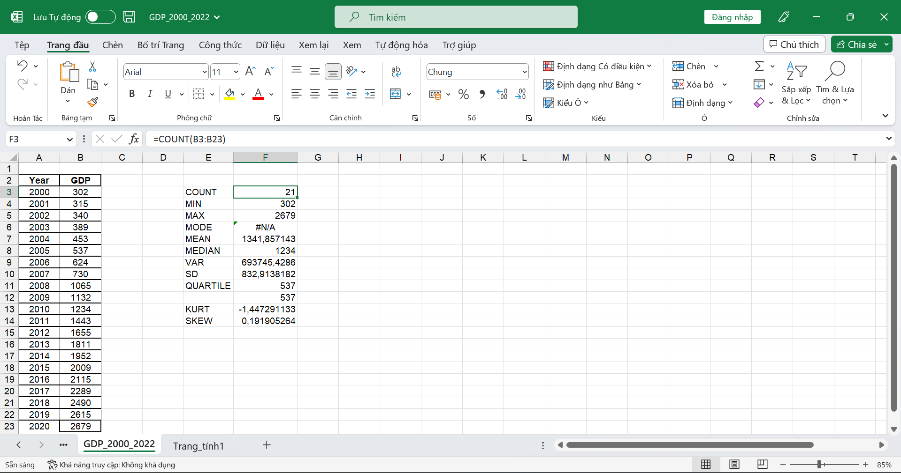

**MIN**

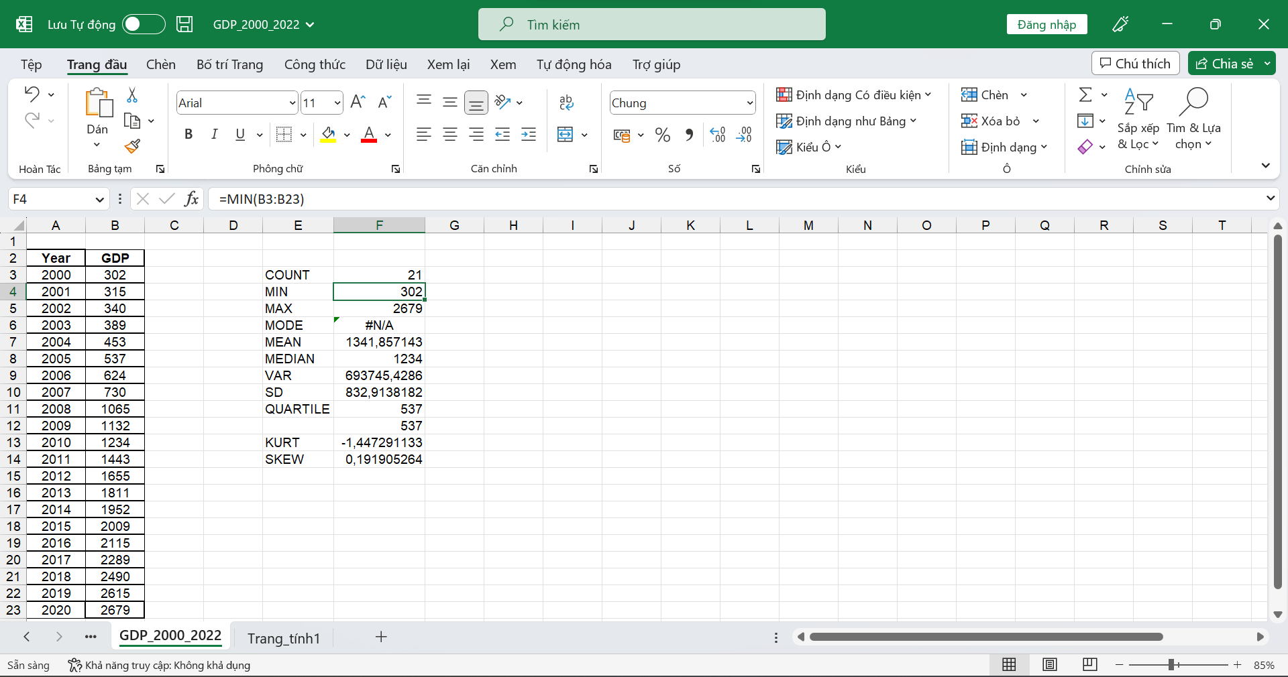

**MAX**

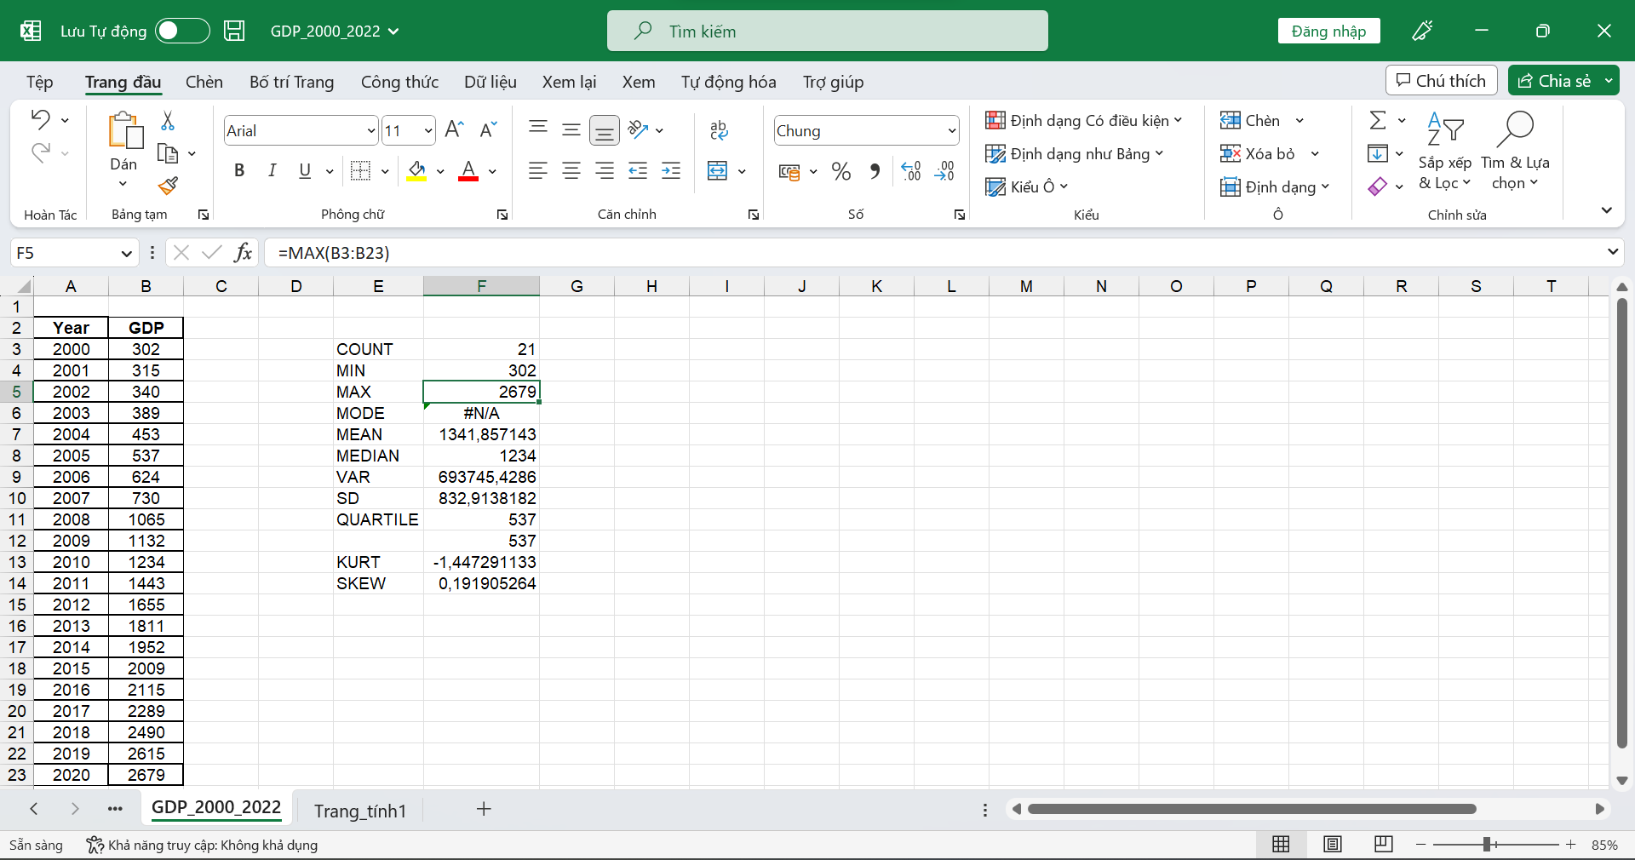

**MODE**

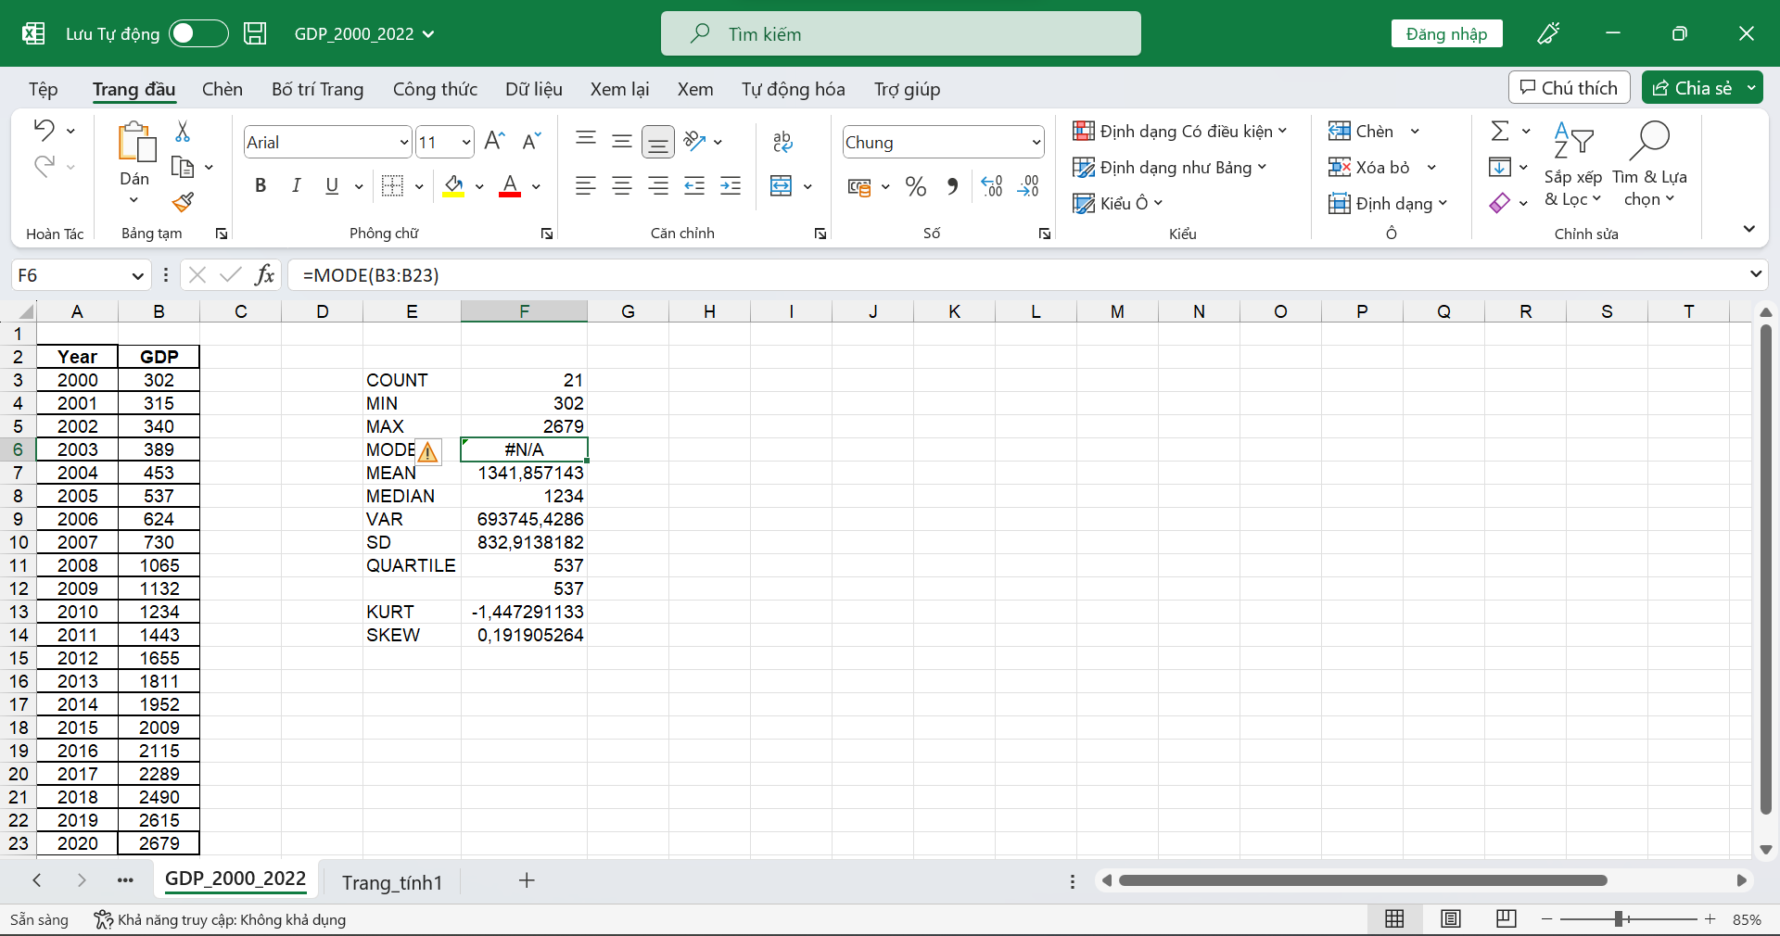

**MEAN**

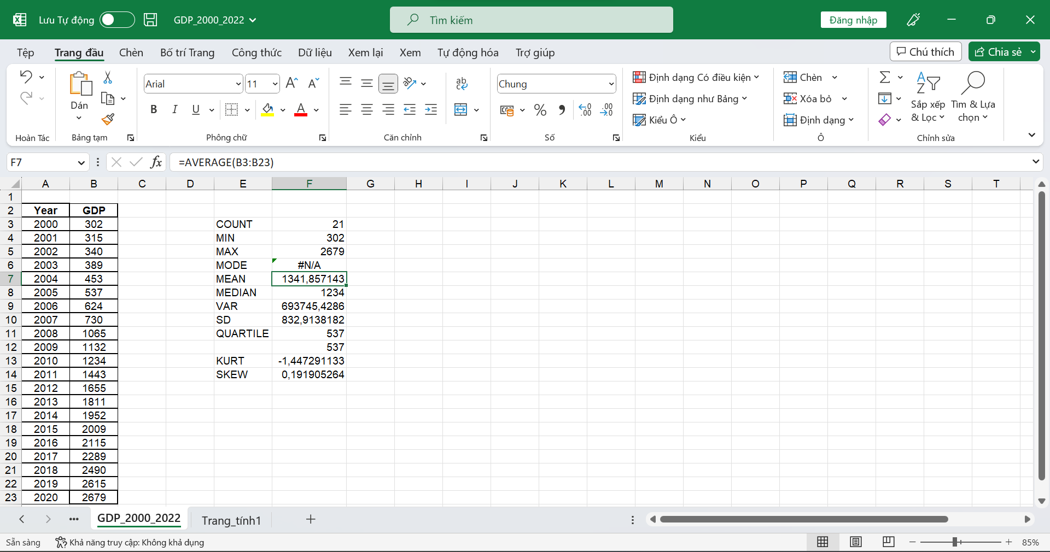

**MEDIAN**

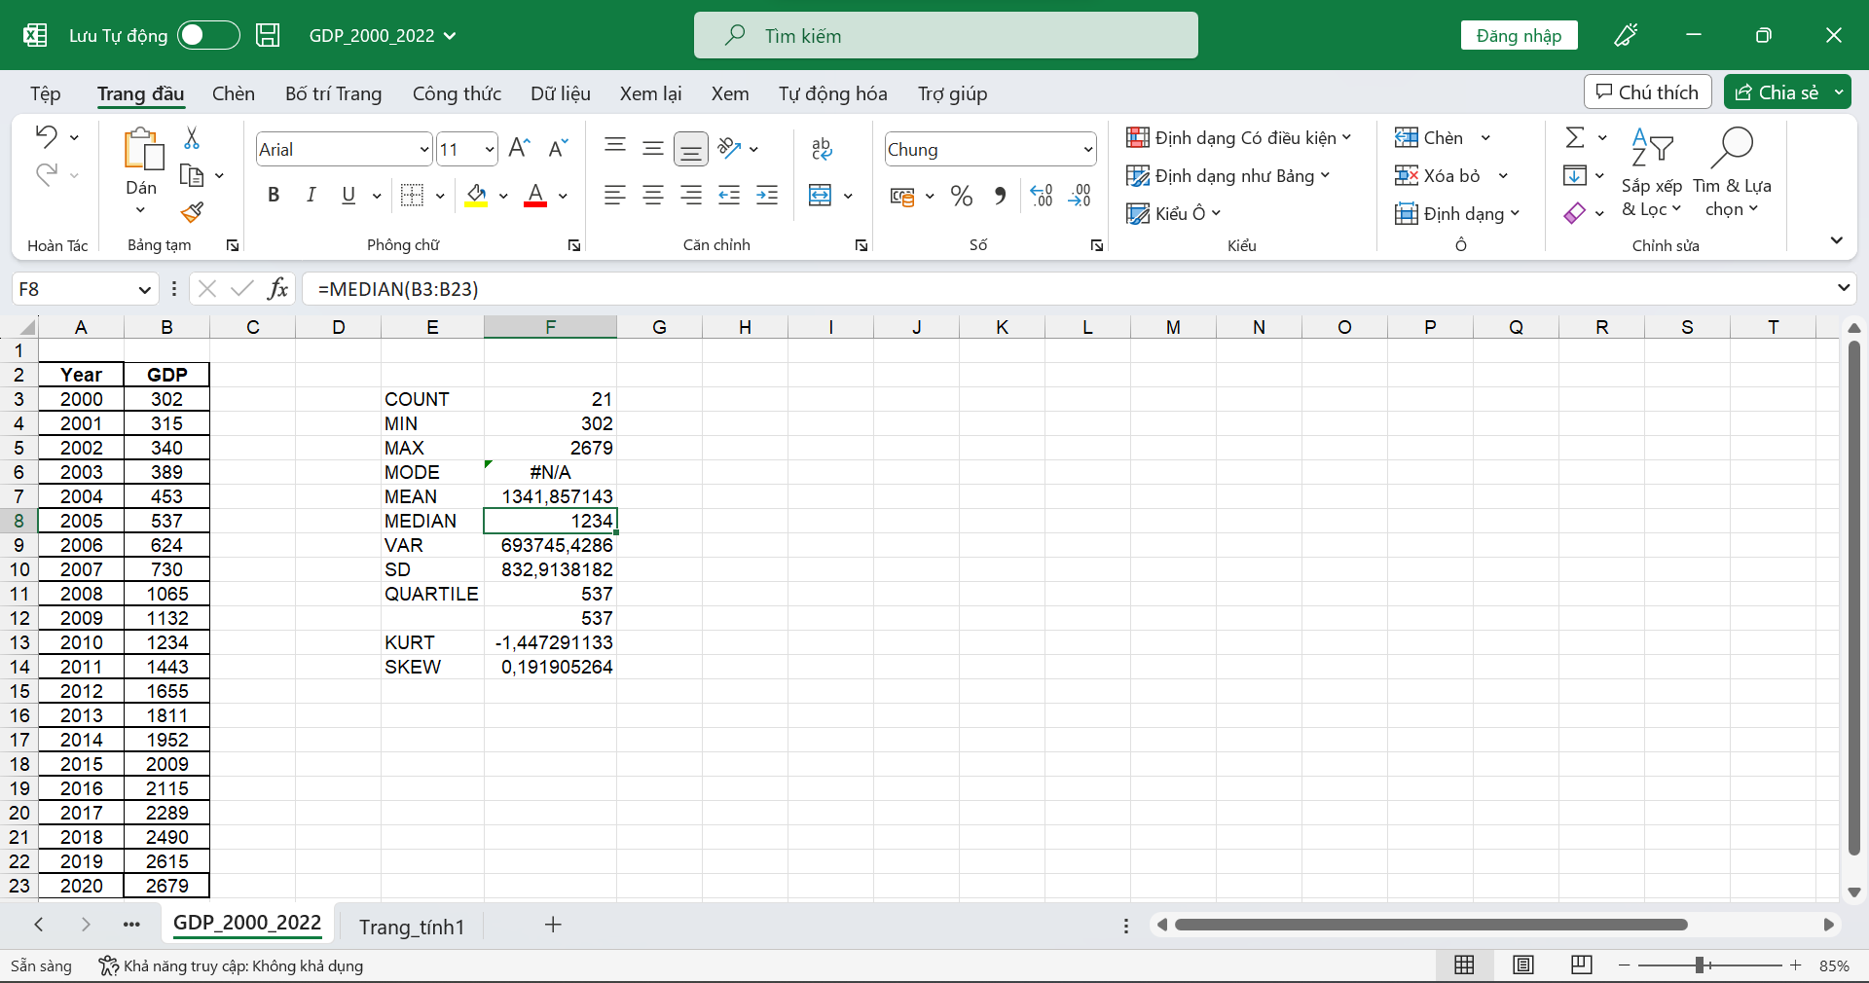

**VAR**

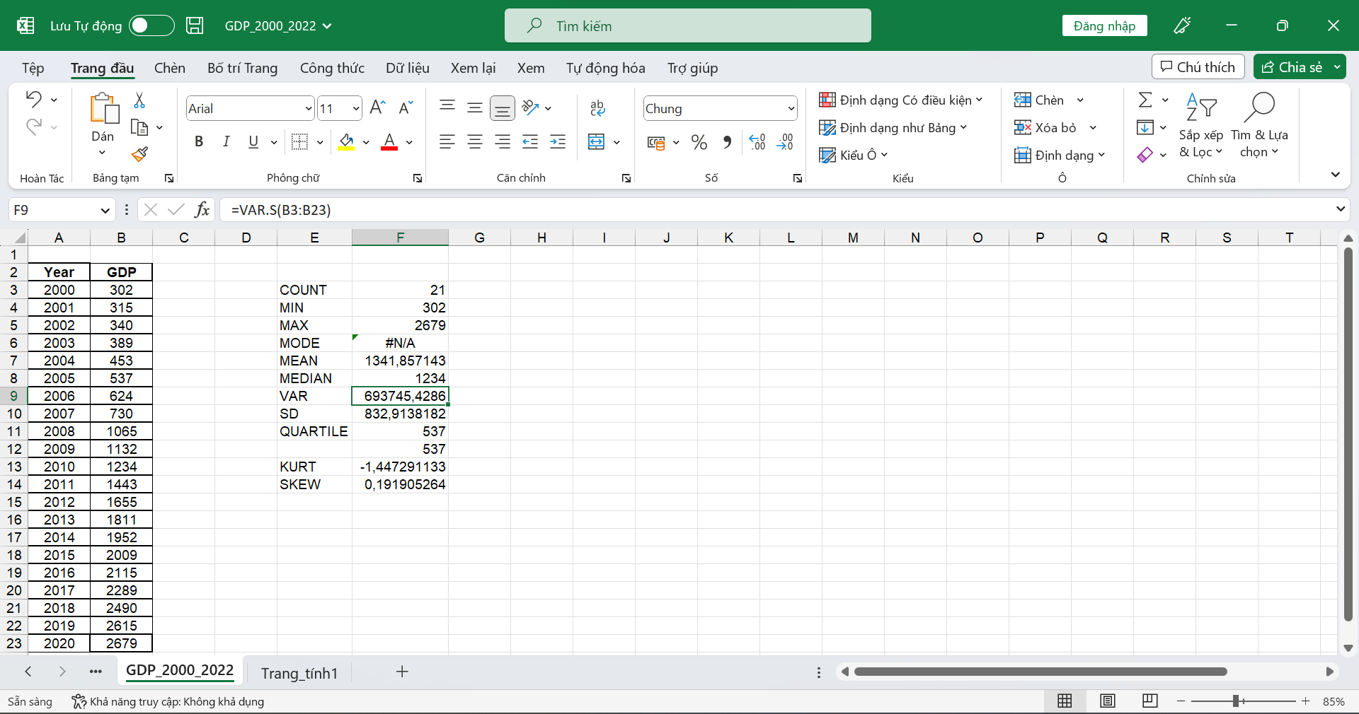

**SD**

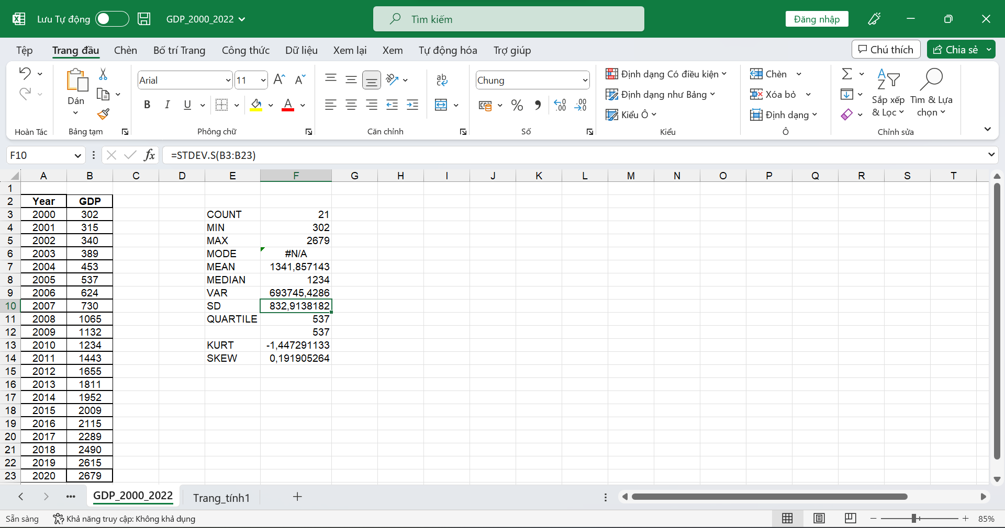

**QUARTILE**

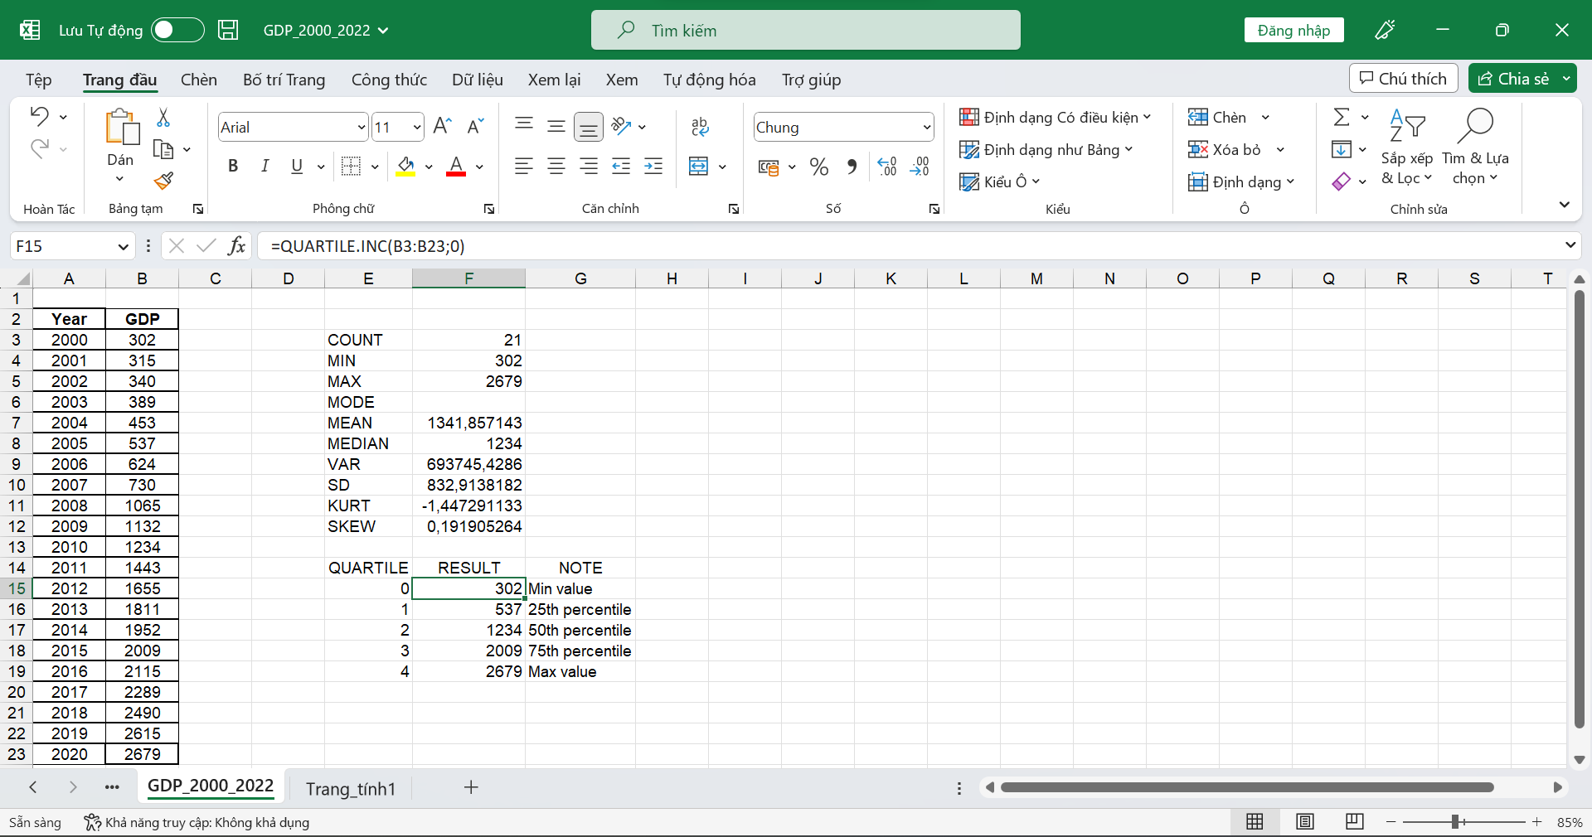

**KURT**

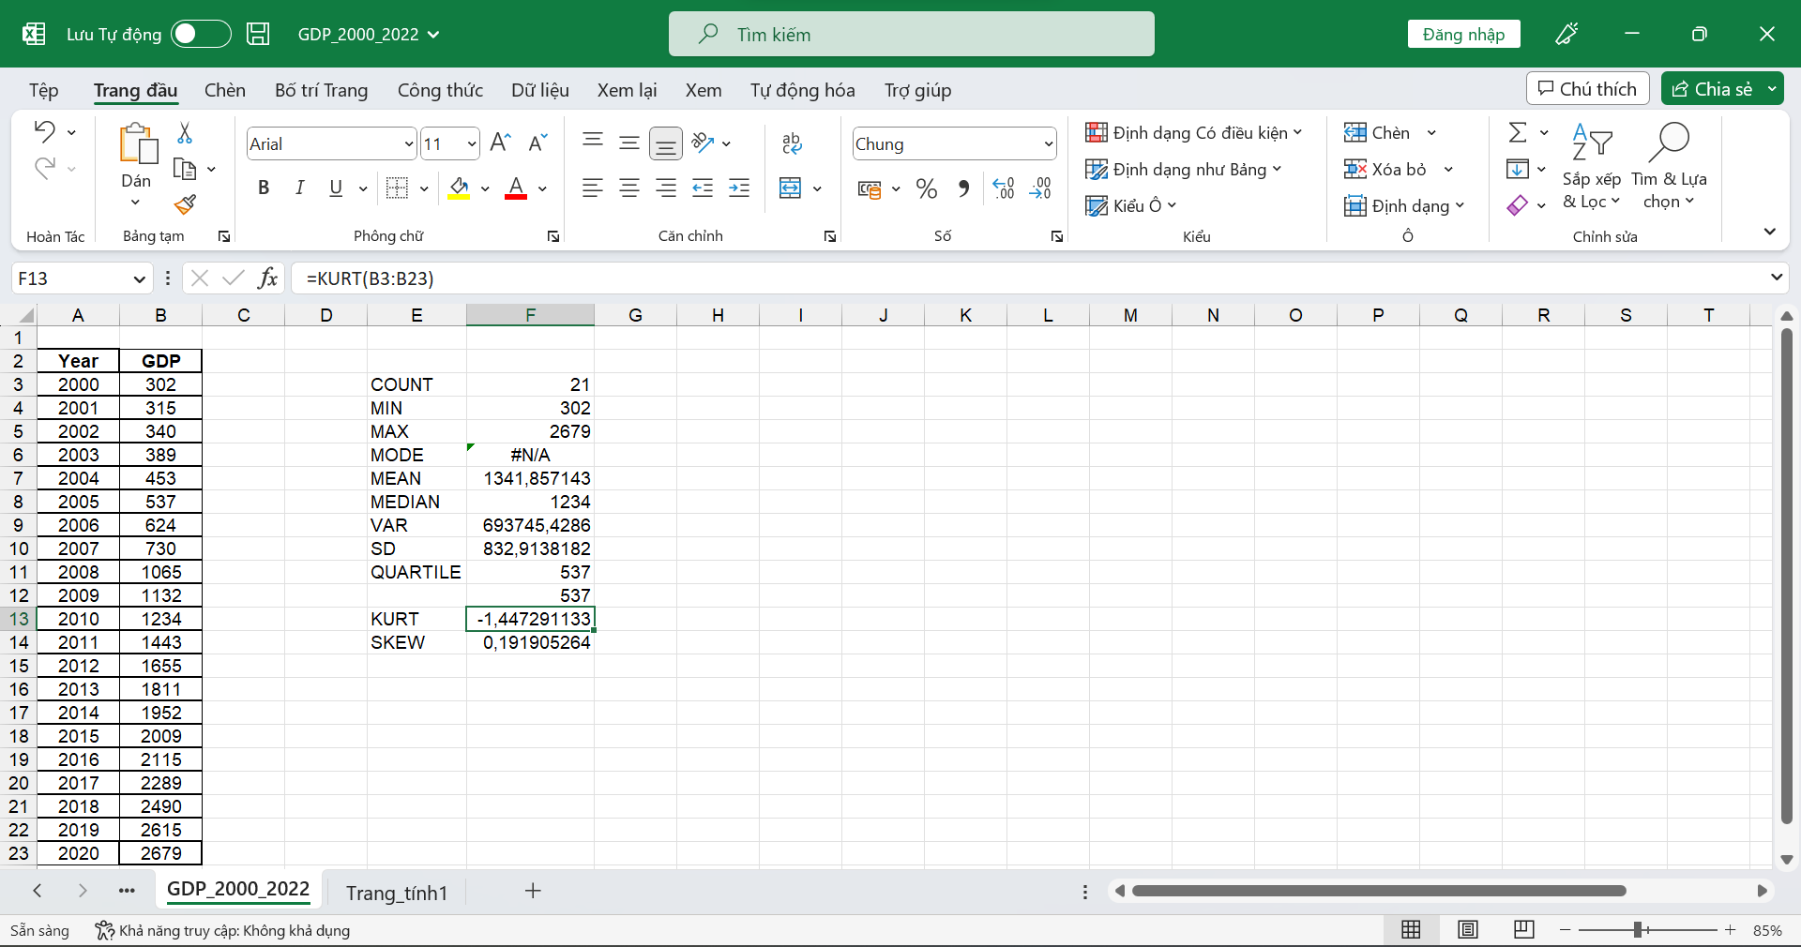

**SKEW**

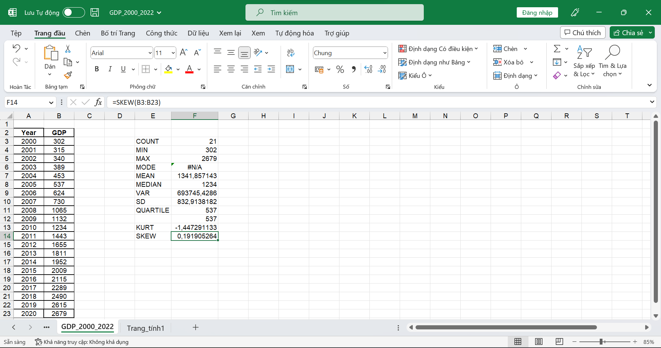

**RANGE**

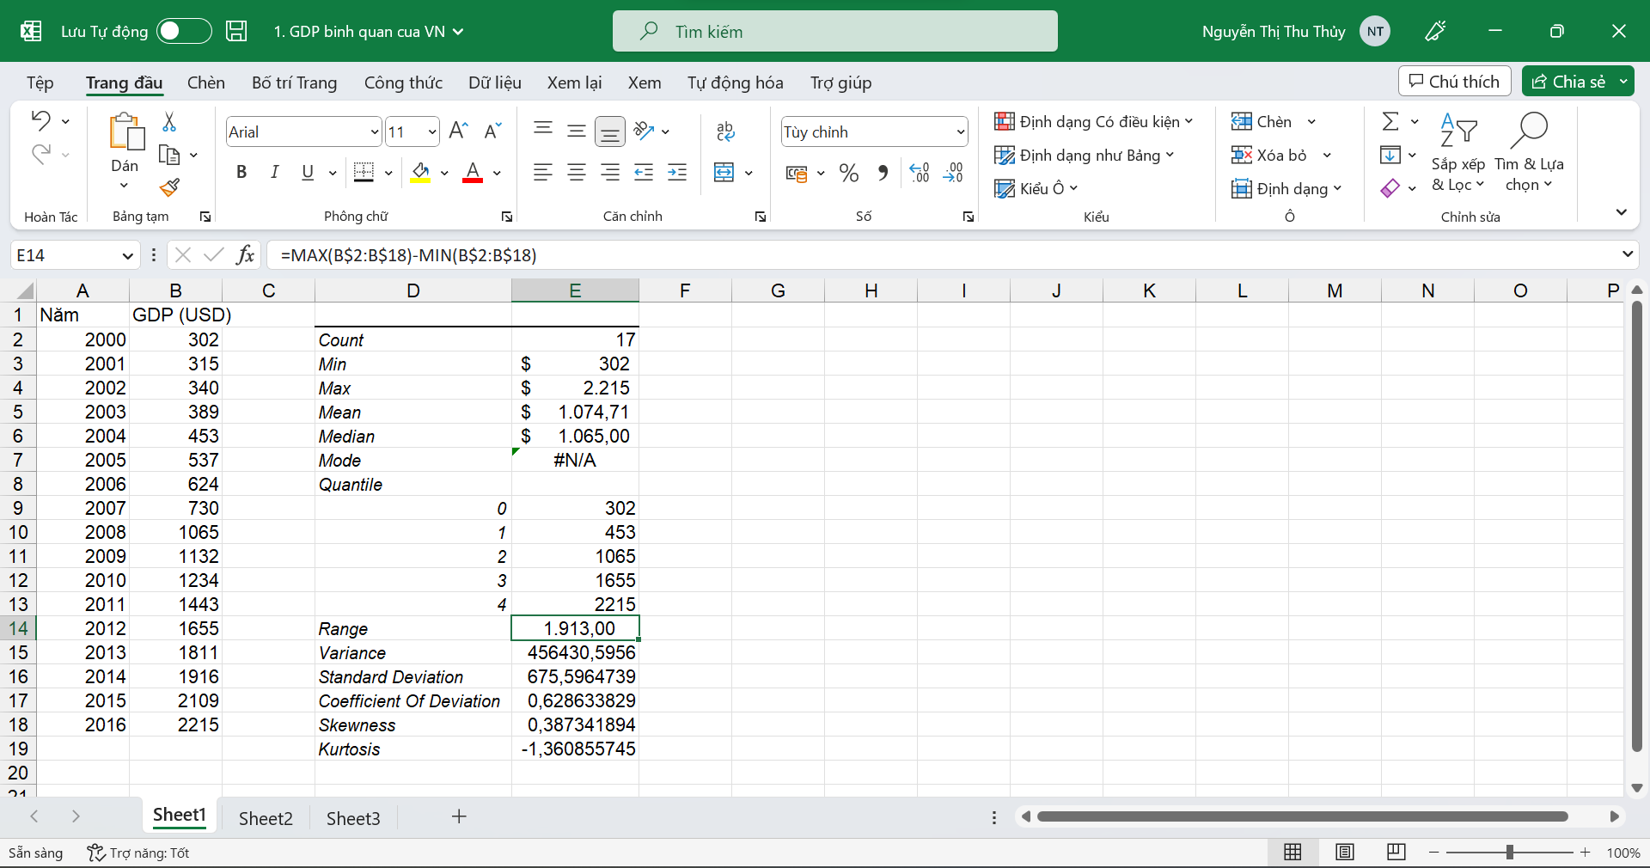

**COEFFICIENT OF DEVIATION**

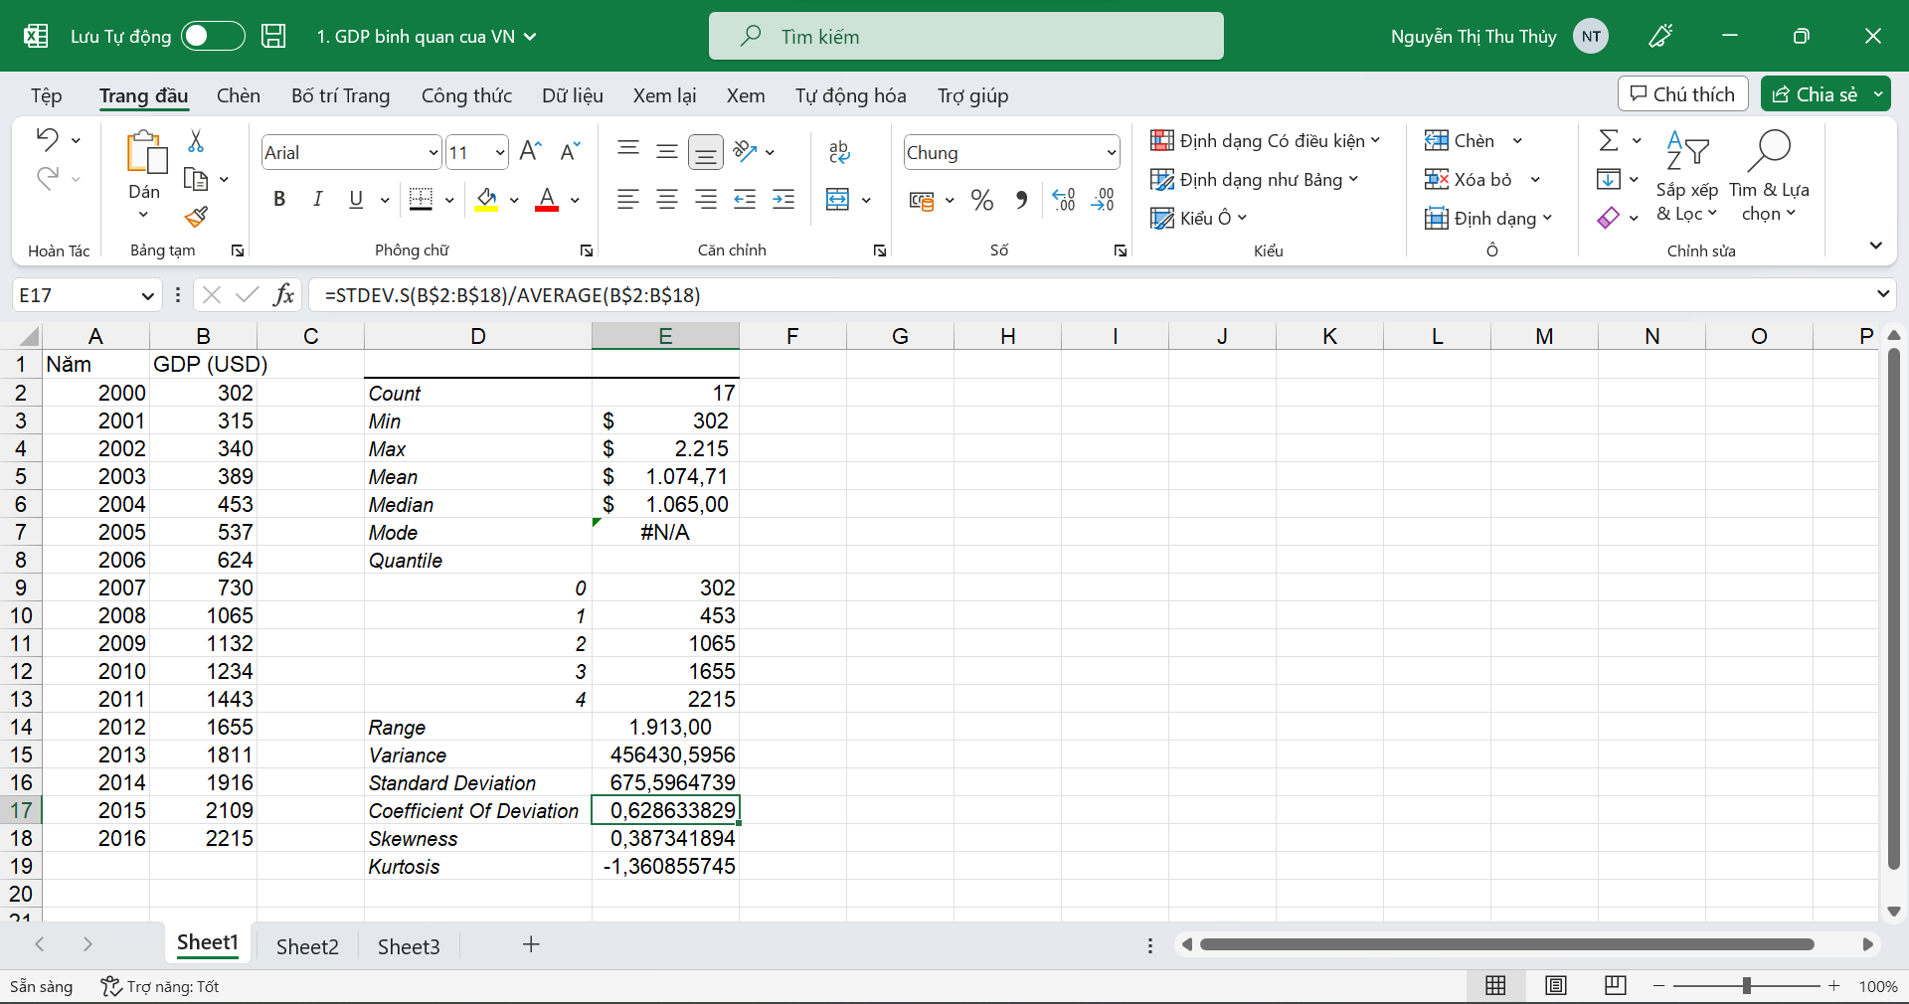

### Using R Programming Language

#### Statistical description

Import dataset from excel file.

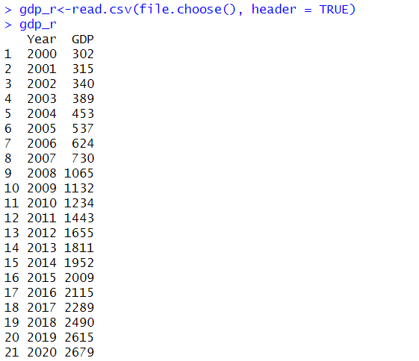

#### Meaning of values

Count:

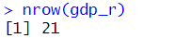

Min:

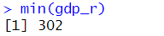

Max:

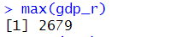

Mean:

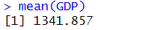

Median:

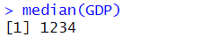

Mode:

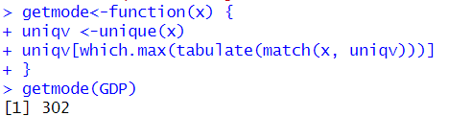

Quantile:

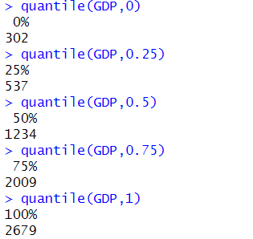

Range:

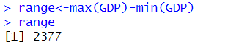

Variance:

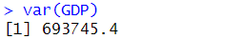

Standard Deviation:

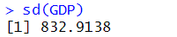

Coefficient of Deviation:

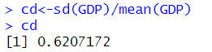

Skewness:

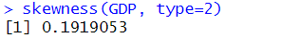

Kurtosis:

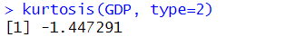

### Using Python Programming Language

#### Statistical description

Import libraries and read dataset from excel file.

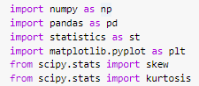

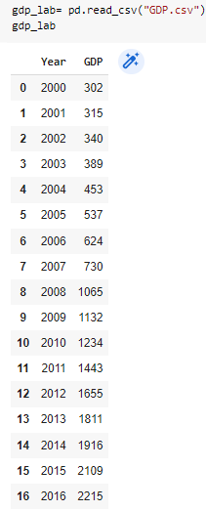

#### Meaning of values

Meaning of the values: Count, Min, Max, Mean, Median, Mode, Quantile, Range, Variance, Standard Deviation, Coefficient of Deviation, Skewness, Kurtosis.

Count:

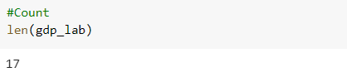

Min:

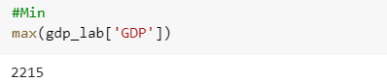

Max:

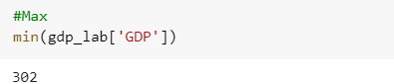

Mean:

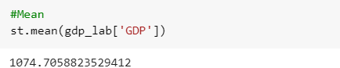

Median:

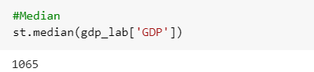

Mode:

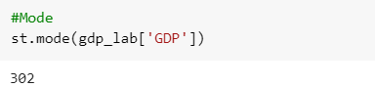

Quantile:

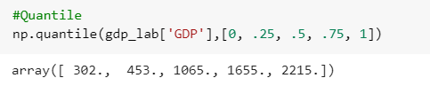

Range:

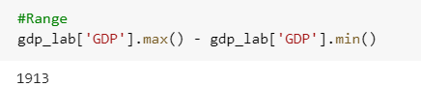

Variance:

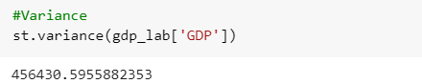

Standard Deviation:

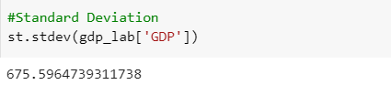

Coefficient of Deviation:

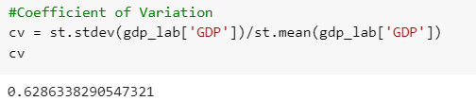

Skewness:

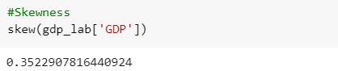

Kurtosis:

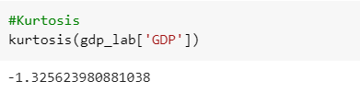

## Data Visualization

### Using MS Excel

#### Histogram

**Step 1:** Choose the “Dữ liệu” tab on the top of the Excel toolbar. Click the “Data Analysis” function. Click “Histogram,” and the “OK” button in the window pops up.

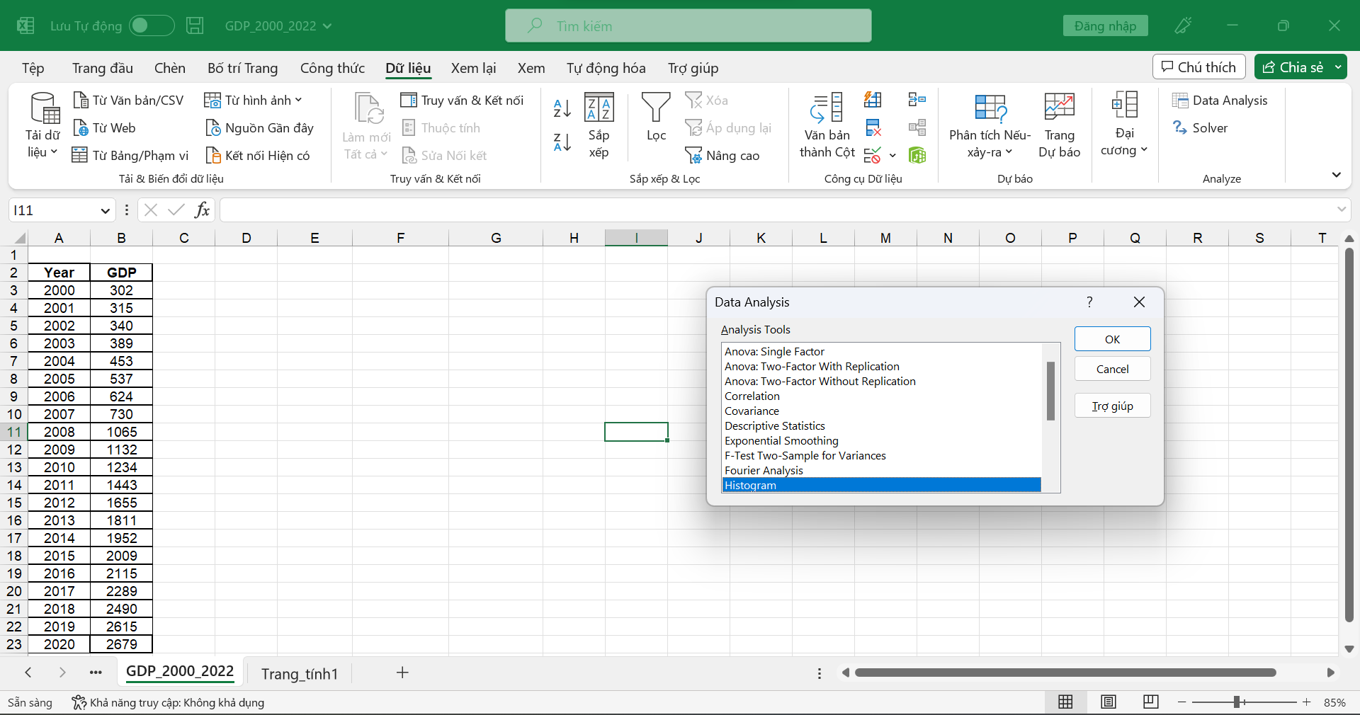

**Step 2:** Enter Input Range and select “Cumulative Percentage” for more specific information about the cumulative percentage and “Chart Output.”

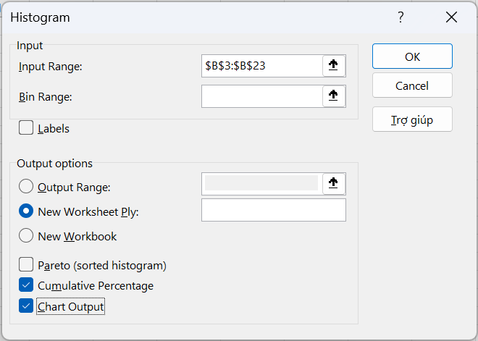

**Step 3:** Get the result

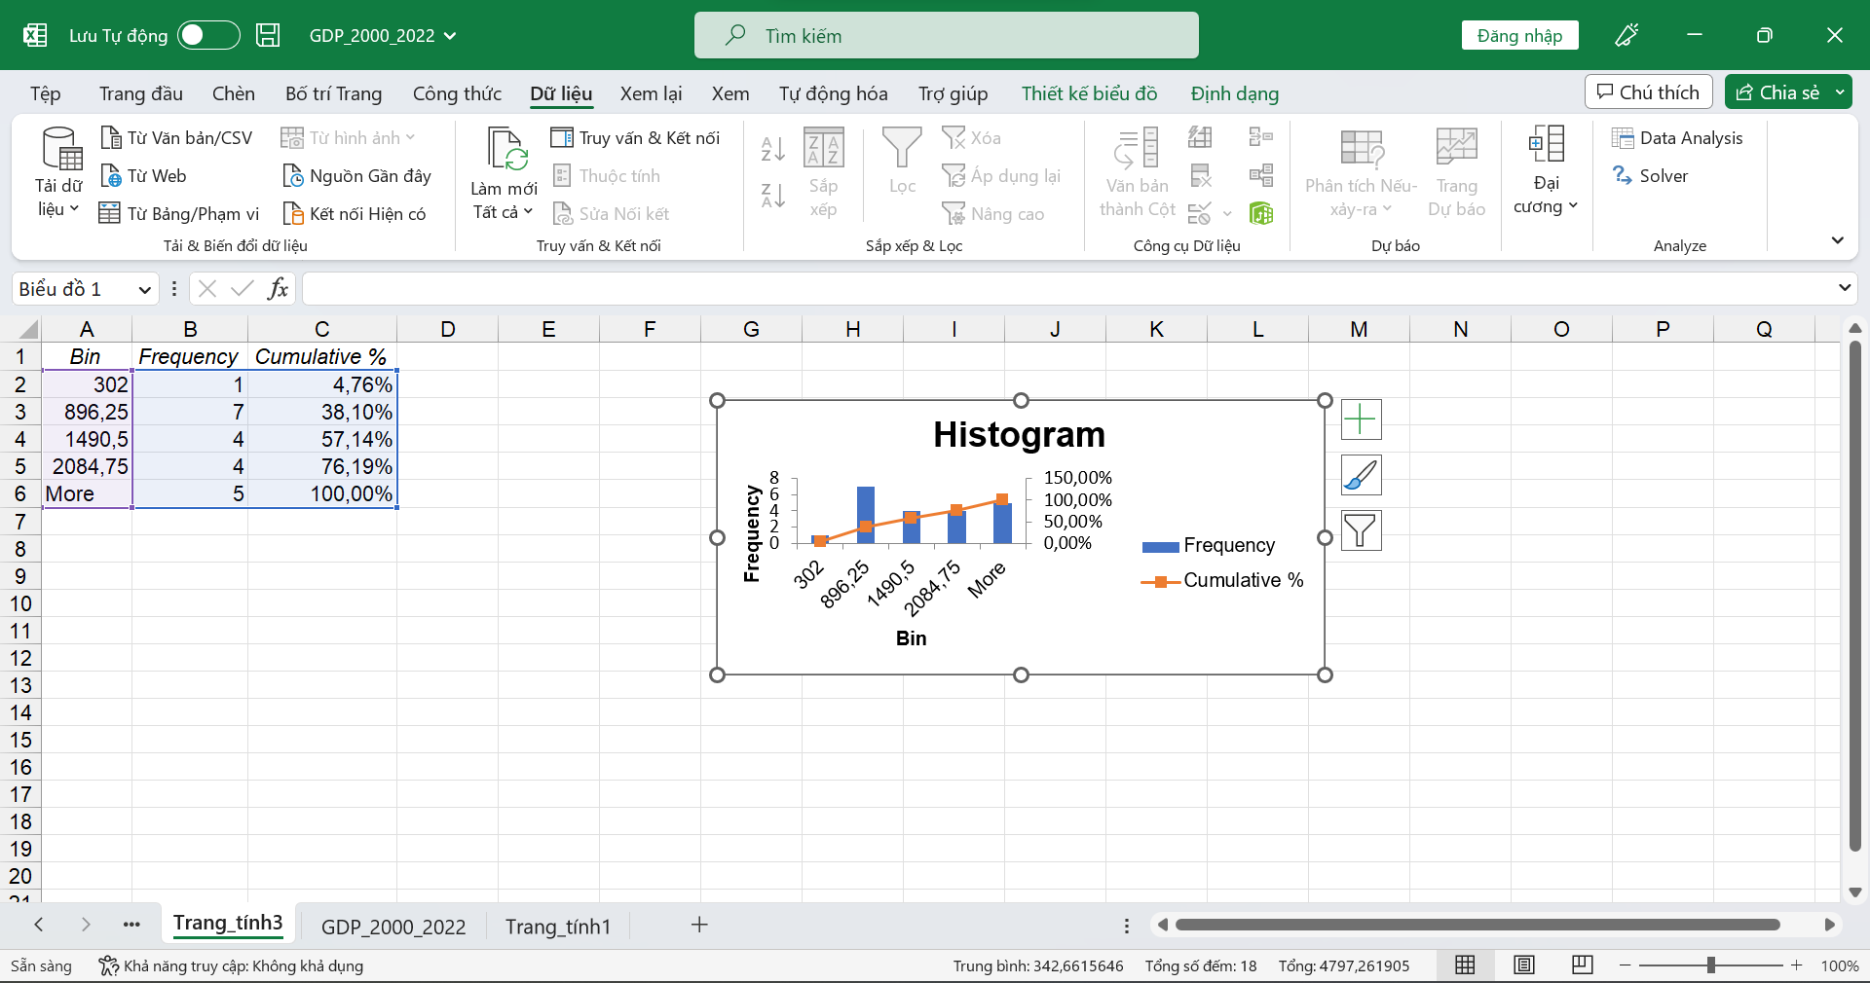

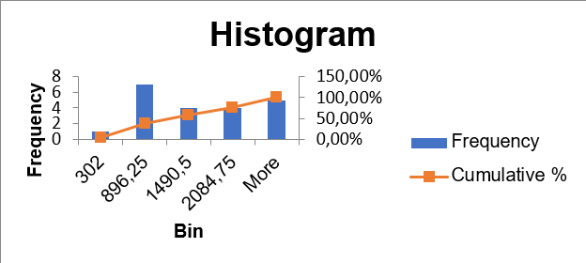

#### Box Plot

**Step 1:** Choose the “Chèn” tab on the top of the Excel toolbar. Click the “Statistic Chart” symbol and “Box and Whisker.”

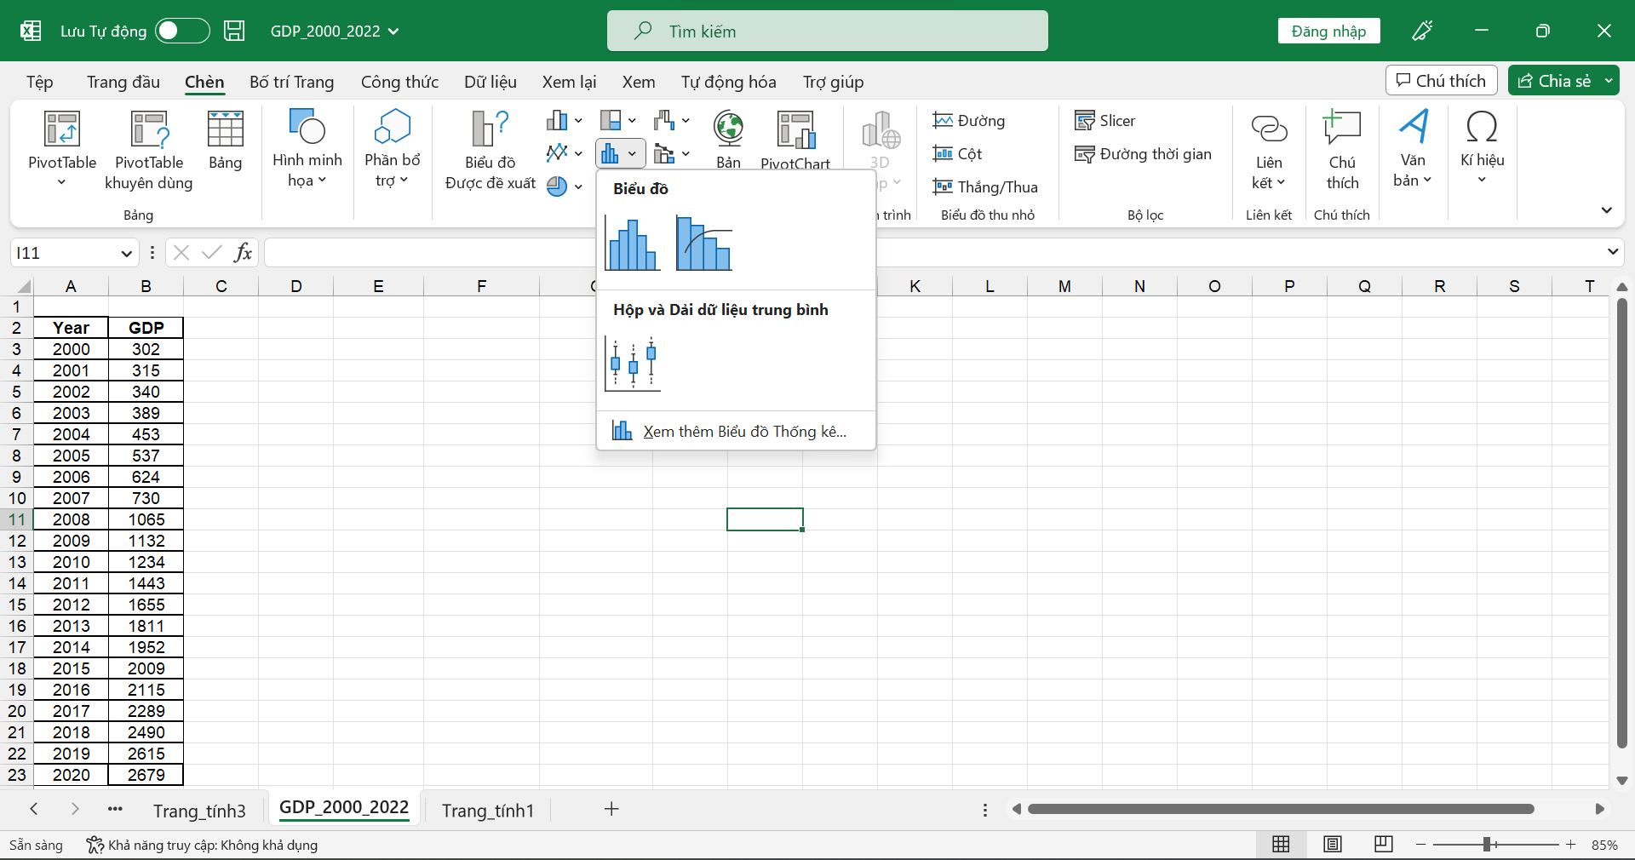

**Step 2:** Get the result

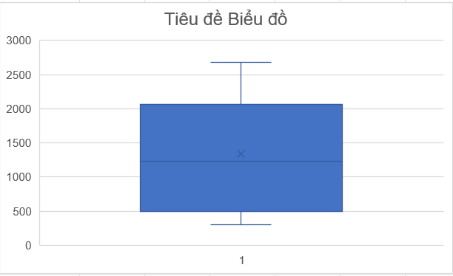

### Using R Programming Language

#### Histogram



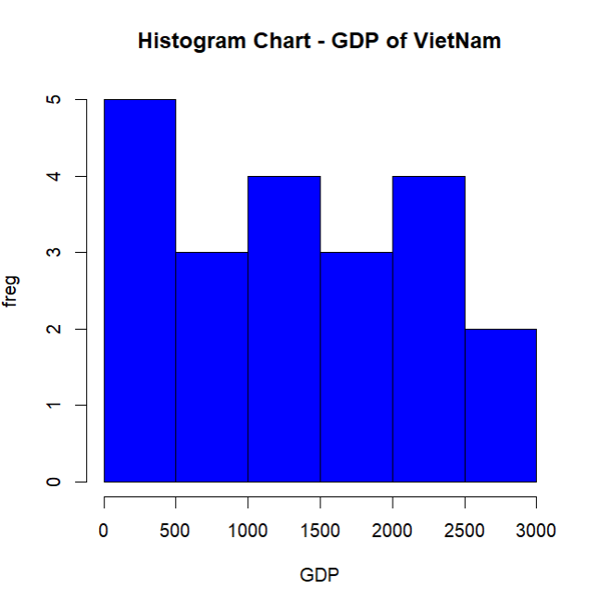

#### Box Plot



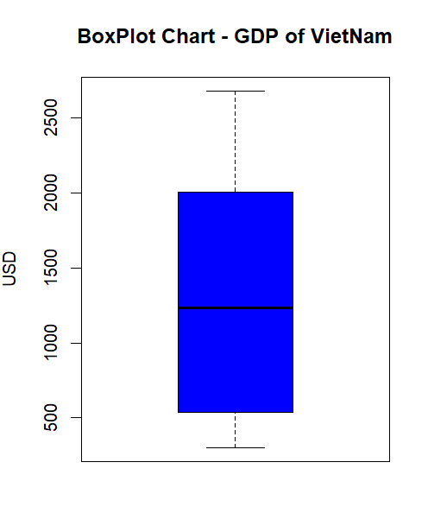

### Using Python Programming Language

#### Histogram

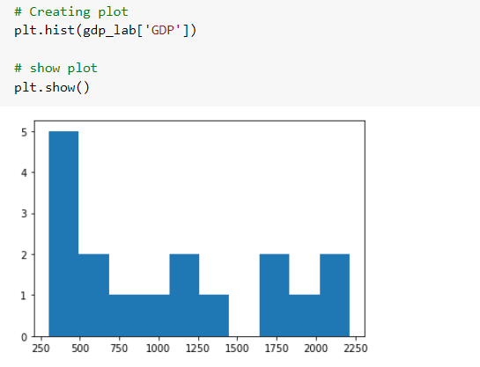

#### Box Plot

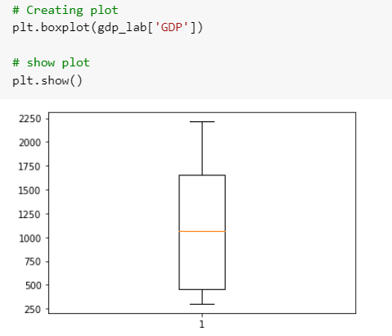

# Purchase Orders

## Using MS Excel, R and Python Programming Language

### Using MS Excel

#### Statistical description

**Step 1:** Go to Data select Data Analysis

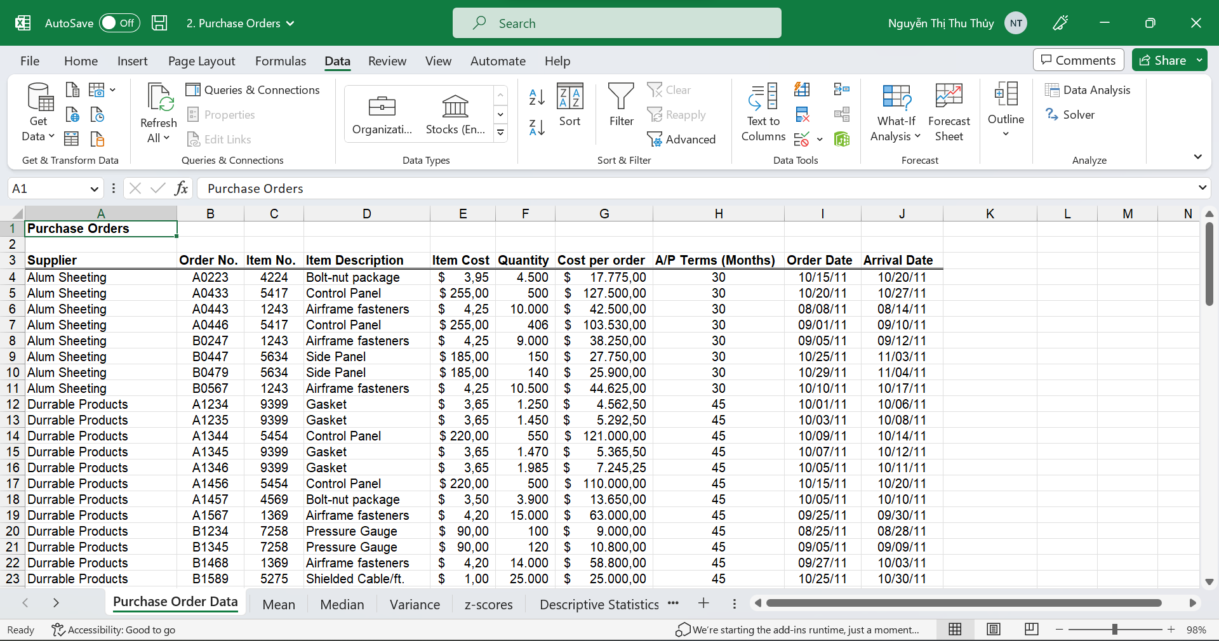

**Step 2:** Select Descriptive Statistics

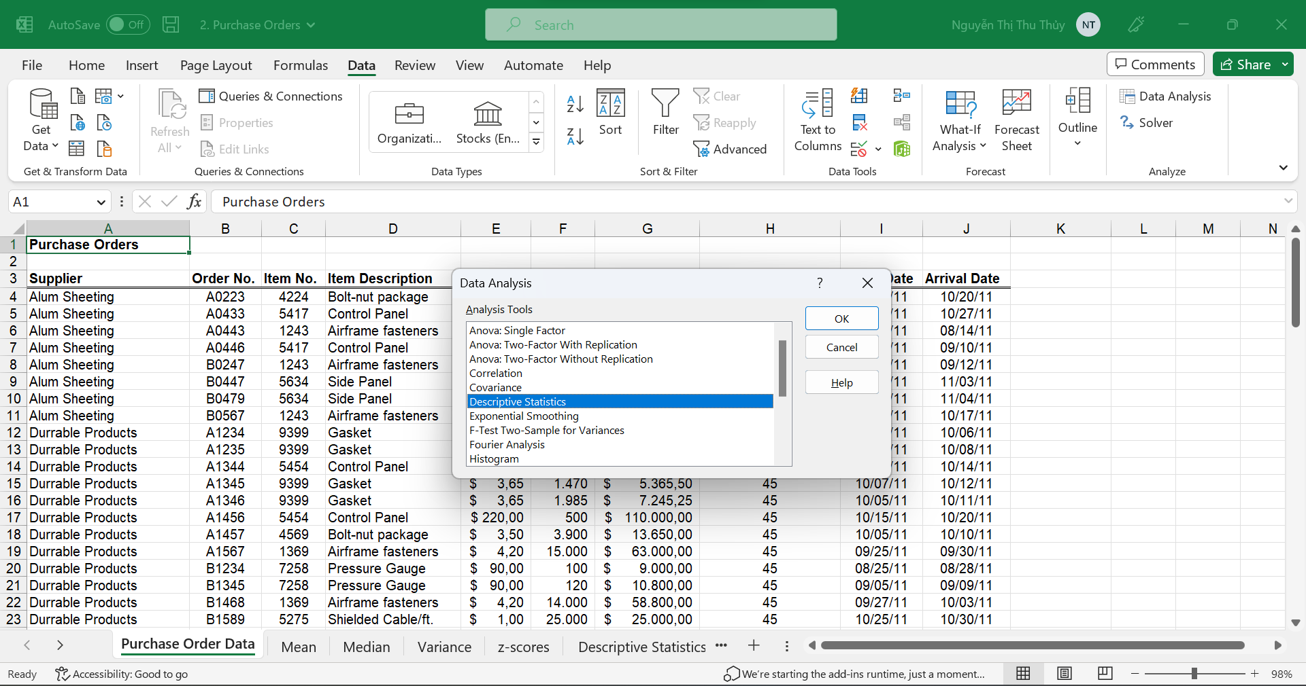

**Step 3:** Enter a date range and Tick the summary statistics box

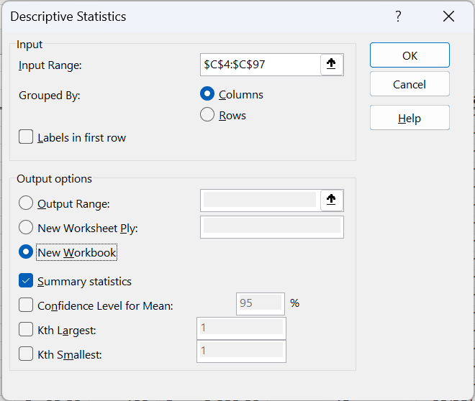

**Step 4:** Get the result

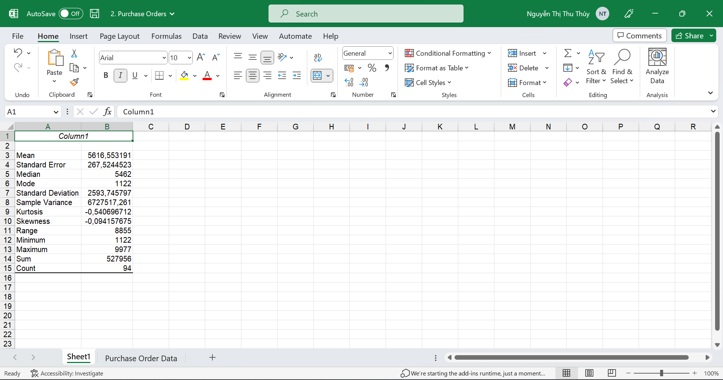

#### Meaning of values

Meaning of the values: Count, Min, Max, Mean, Median, Mode, Quantile, Range,

Mode, Variance, Standard Deviation, Coefficient of Deviation, Skewness, Kurtosis.

**Count:** This counts the number of cells containing numeric data in a Data range (range) in all observations. COUNT (data range)

**Min**: This is the smallest value of all observations. MIN (data range)

**Max**: This is the maximum value of all observations. MAX (data range)

**Mean**: The arithmetic means of a variable, calculated as the sum of the observations divided by the number of words. MEAN (data range)

**Median**: The middle number (if the number of observations is odd) or the average value of two central observations (if the number of observations is even) of a sequence of observations arranged in ascending order gradually. MEDIAN (data range)

**Mode**: The value with the highest frequency of a set of measurements. MODE (data range)

**Quartile**: The quartile is a quantity that describes the distribution and dispersion of data. It has three values, the 1st quartile (Q1), the 2nd quartile (Q2), and the 3rd quartile (Q3). These three values divide a data set (sorted in ascending order) into four parts with an equal number of observations.

* Min value: QUARTILE.INC (data range, 0)
* First quartile: QUARTILE.INC (data range, 1)
* Median value: QUARTILE.INC (data range, 2)
* Third quartile: QUARTILE.INC (data range, 3)
* Max value: QUARTILE.INC (data range, 4)

**Range**: Is the distance between the smallest observed value to the most significant observed value. RANGE = MAX – MIN

**Variance**: Used to measure the dispersion of a set of observations around the mean of that set of observations. The variance is the mean of the squares of the deviations between the observations for the standard of those observations. VARIANCE =VAR.S (Data range)

**Standard Deviation:** The principal standard deviation equal to the square root of the variance, used to measure the dispersion of data around its mean. STDE.S(Data range)

**Coefficient of Deviation:** The coefficient of variation is used to measure the relative volatility of undisaggregated data sets with different mean values. This coefficient is calculated by dividing the standard deviation by the mean: STDE.S/AVERAGE

**Skewness**: shows the distribution of observed values that can be used to test for normal distribution. A positive Skewness value indicates that the branch of this distribution is skewed to the right, and a negative value indicates that the addition of this distribution is extended to the left.

* Skewness < 0: Observations mainly focus on the smallest values.
* Skewness = 0: Observations are distributed symmetrically around the mean.
* Skewness > 0: Observations mainly focus on the maximum values.

**Coefficient of Skewness** = SKEW (data, range)

**Kurtosis**: refers to peakedness or flatness. Kurtosis is used to evaluate the peak of the observation curve in the form of a standard distribution curve.

* Kurtosis = 3: the distribution is Mesokurtic: the normal distribution
* Kurtosis > 3: the distribution is Leptokurtic: the distribution has fatter tails and a sharper peak.
* Kurtosis < 3: the distribution is Platykurtic: the distribution has a lower and broader elevation and thinner tails

**Coefficient of Kurtosis** = KURT (data, range)

#### Recalculation using Excel

**Count**

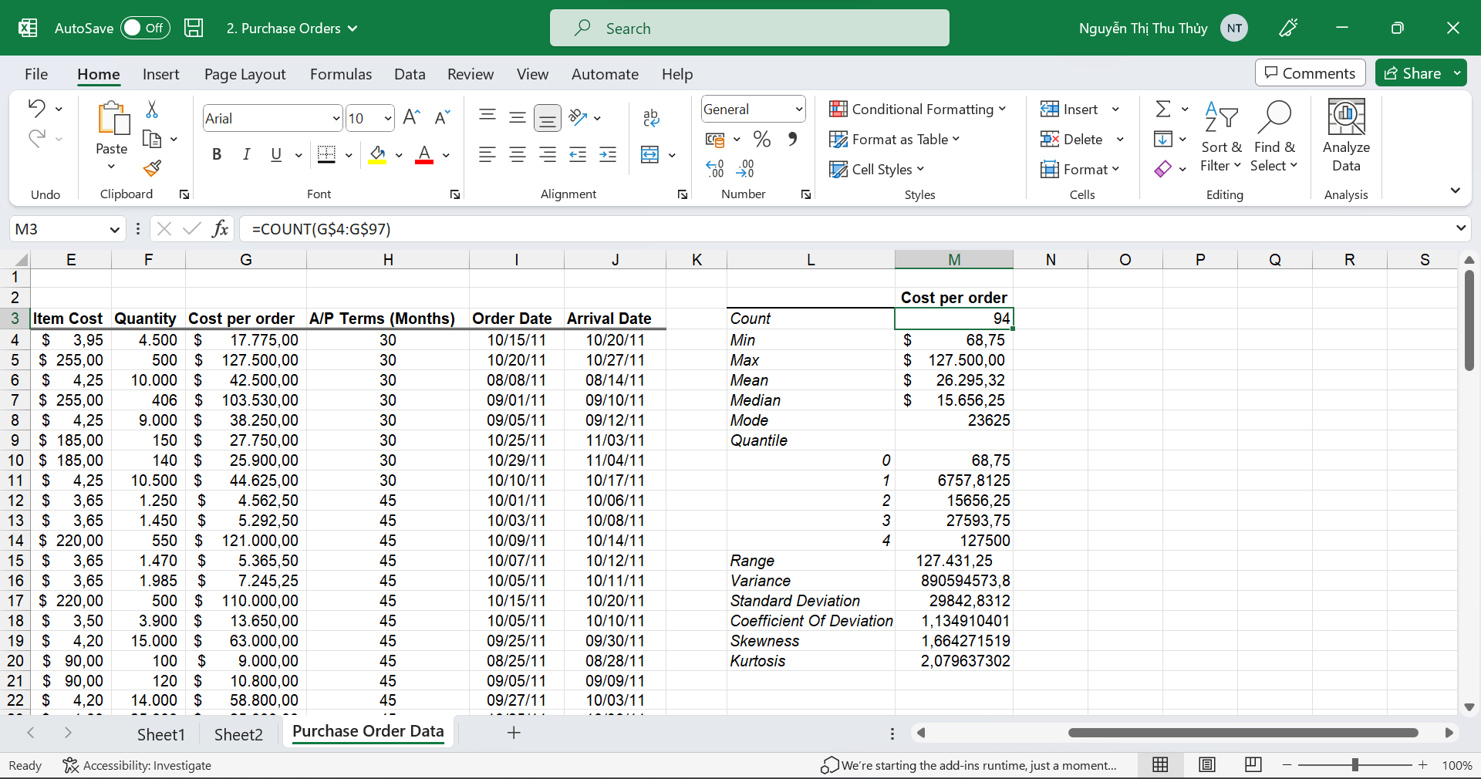

**Min**

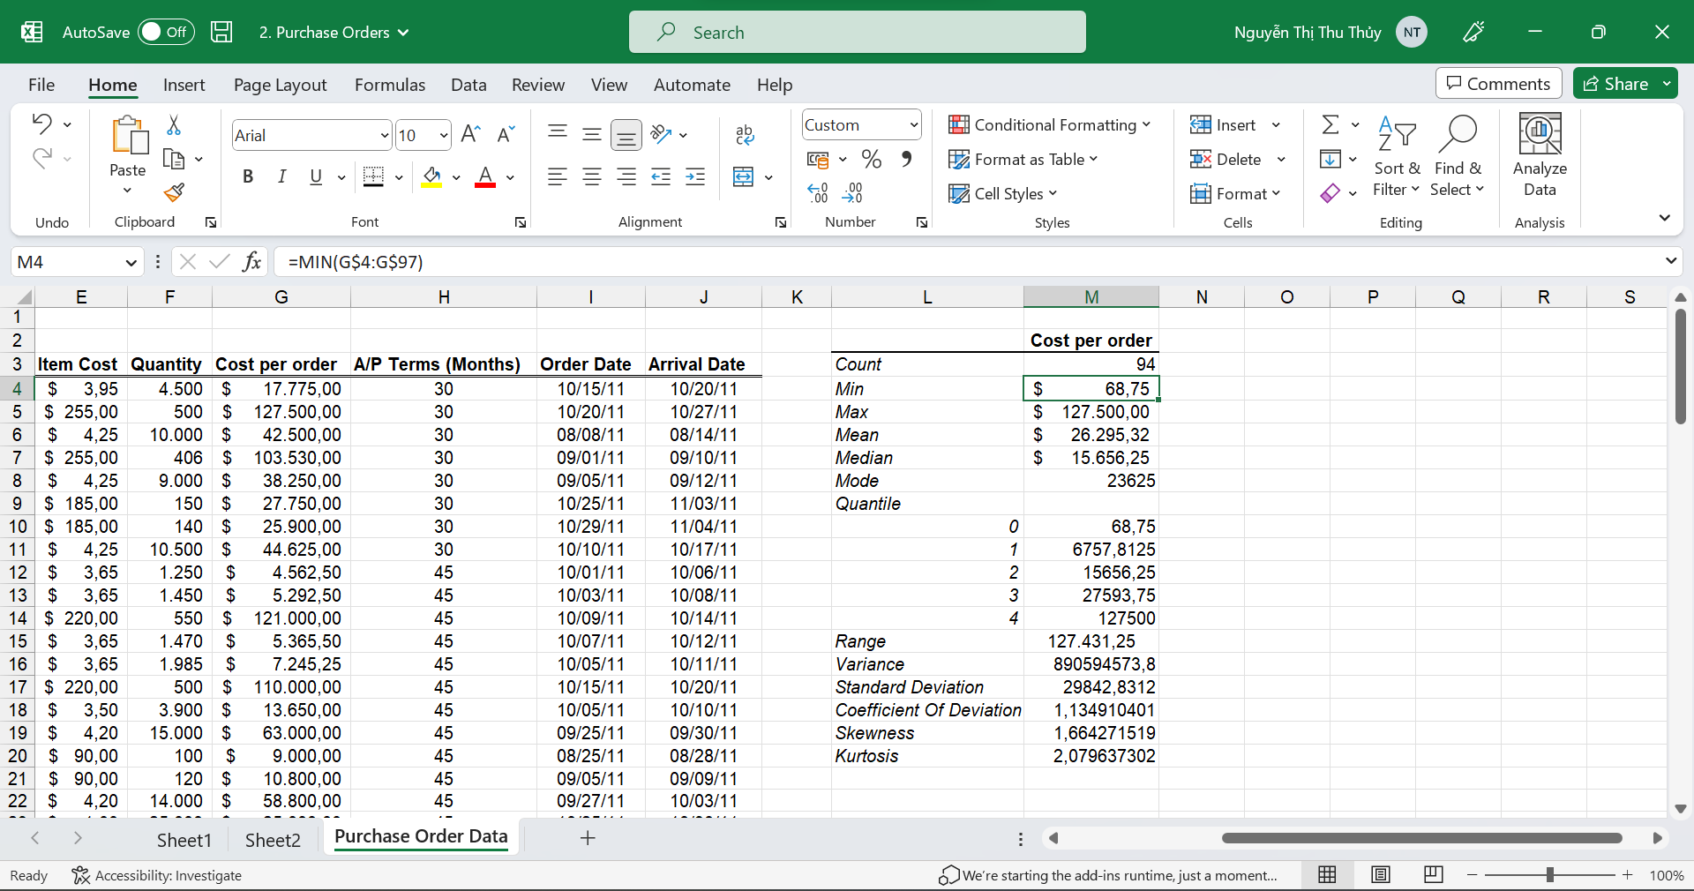

**Max**

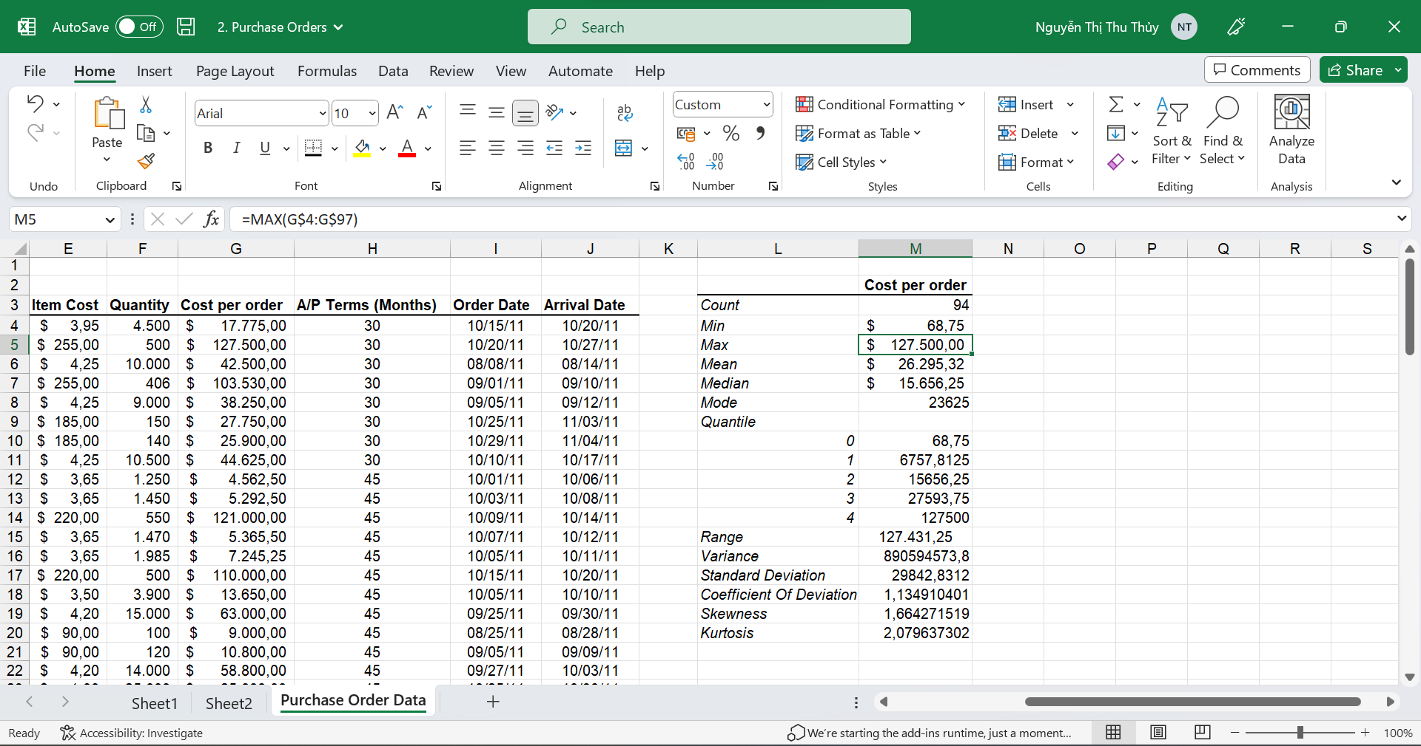

**Mean**

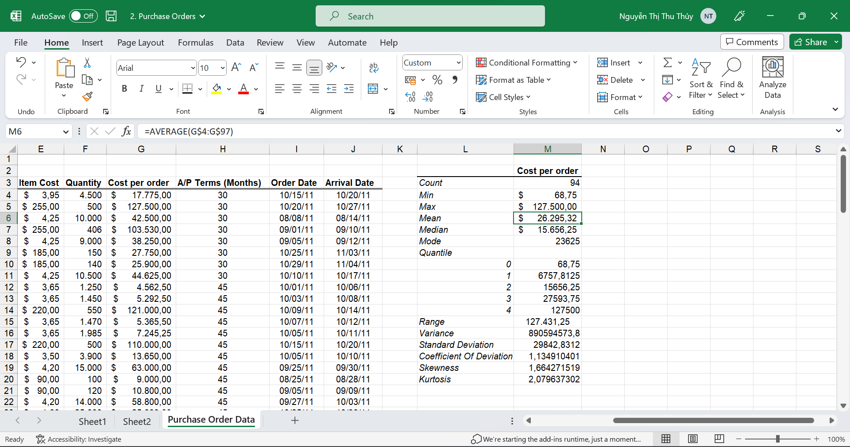

**Median**

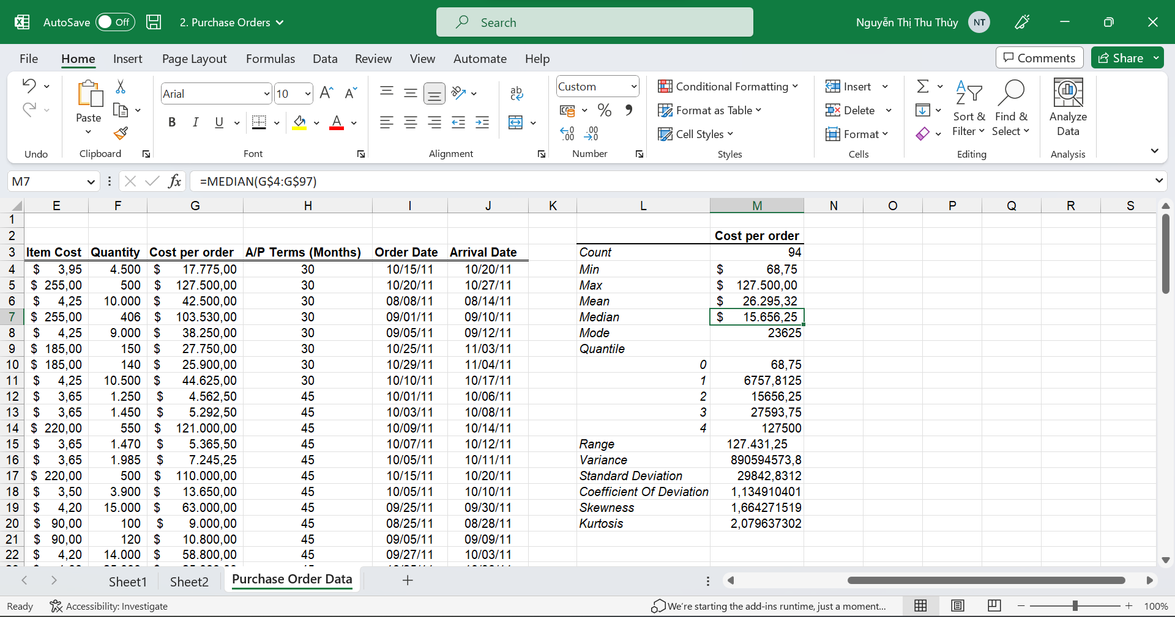

**Mode**

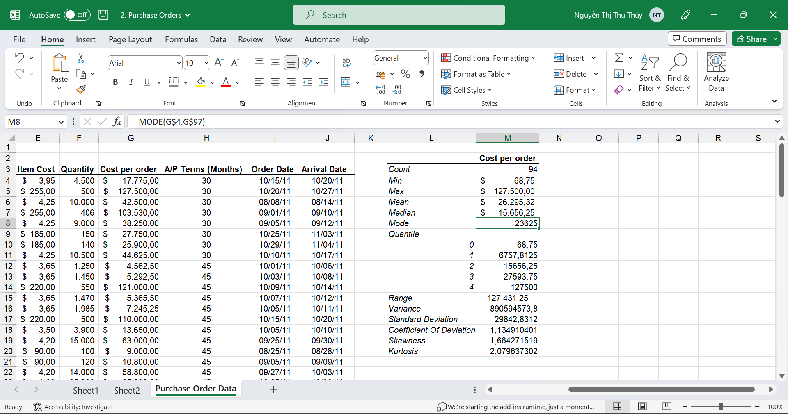

**Quartile**

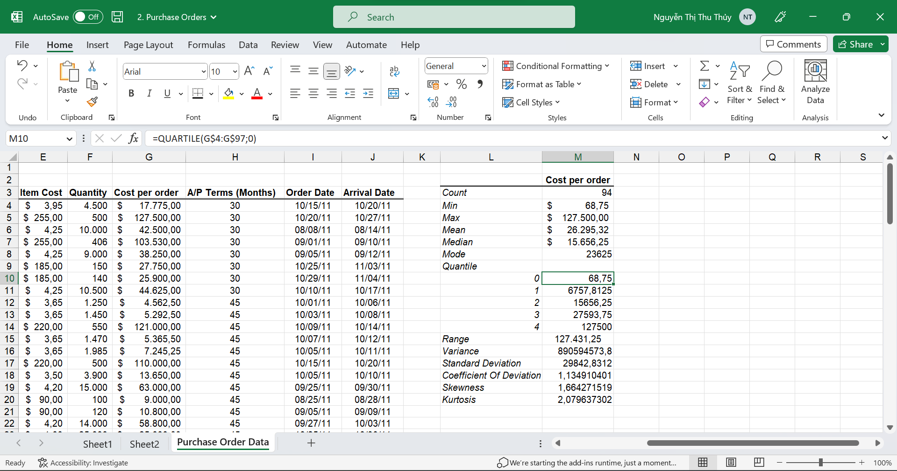

**Range**

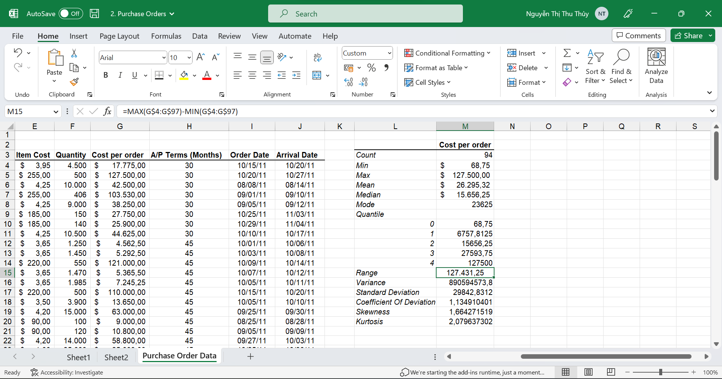

**Variance**

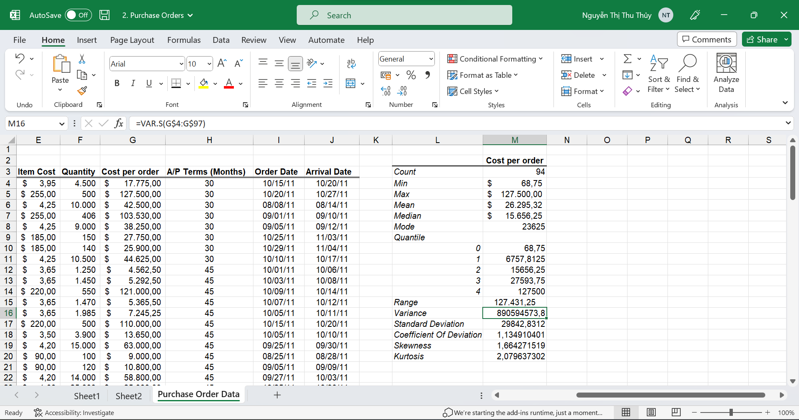

**Standard Deviation**

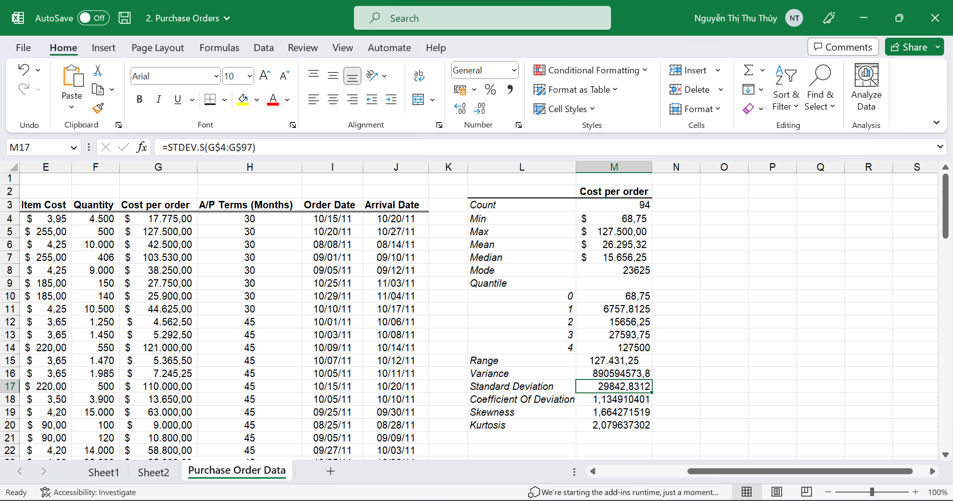

**Coefficient Of Deviation**

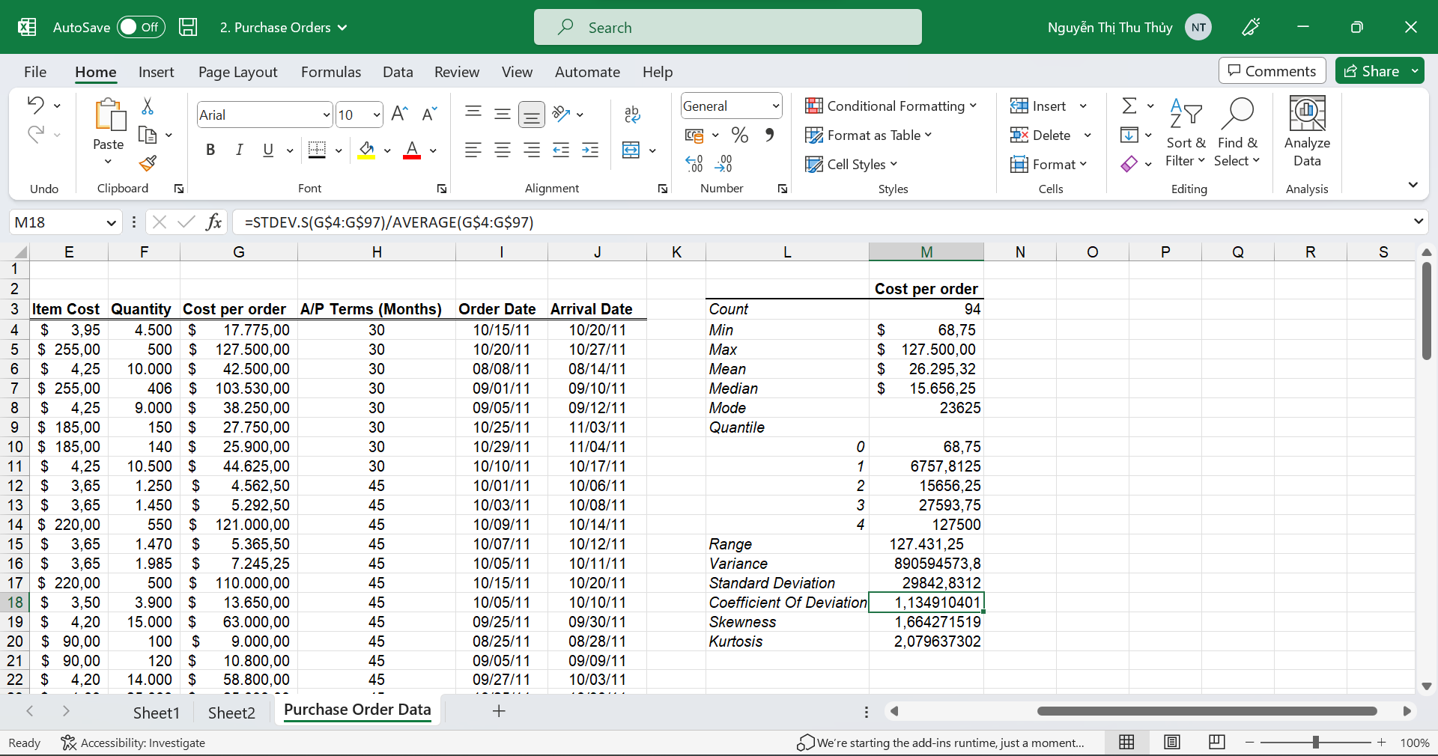

**Skewness**

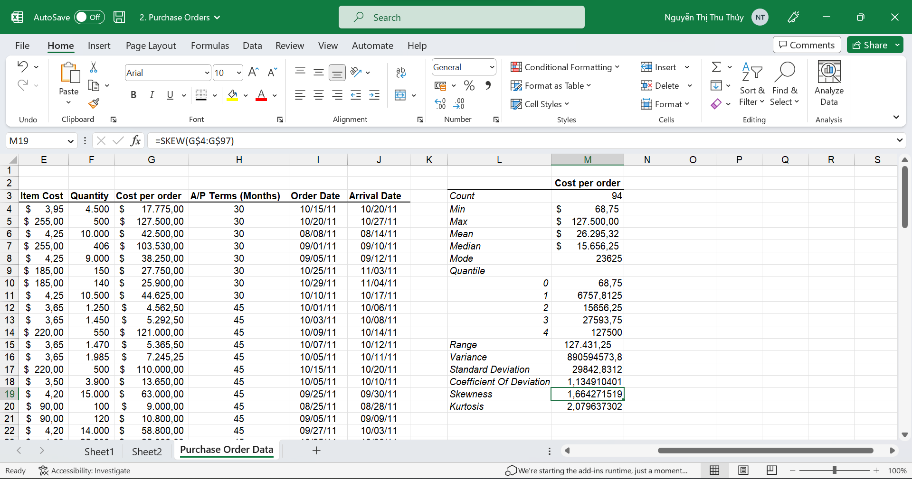

**Kurtosis**

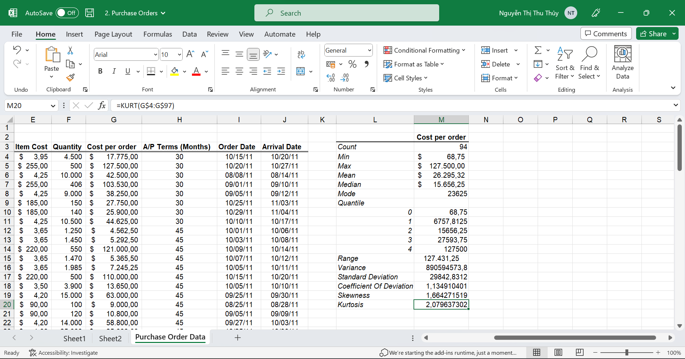

### Using R Programming Language

#### Statistical description

Import dataset from excel file.

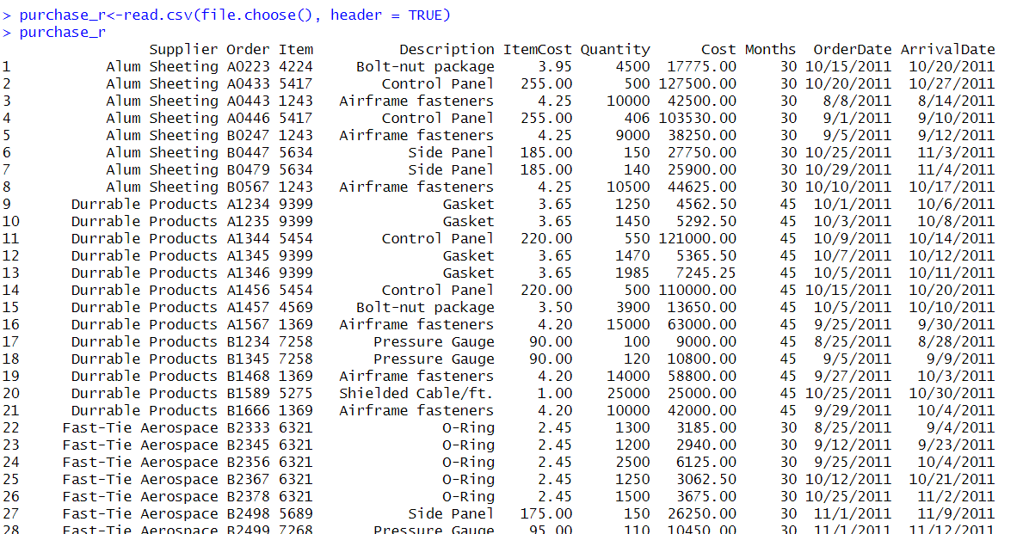

#### Meaning of values

Count:

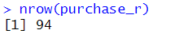

Min:

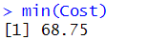

Max:

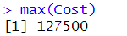

Mean:

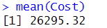

Median:

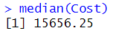

Mode:

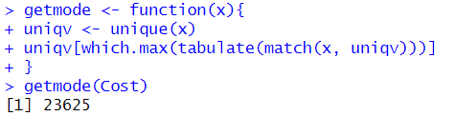

Quantile:

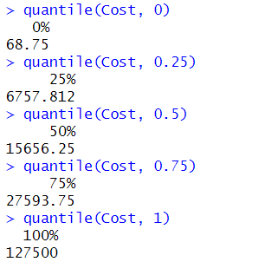

Range:

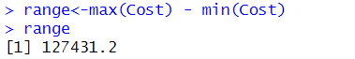

Variance:

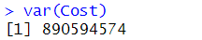

Standard Deviation:

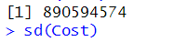

Coefficient of Deviation:

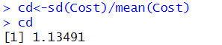

Skewness:

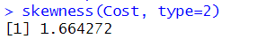

Kurtosis:

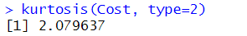

### Using Python Programming Language

#### Statistical description

Import libraries and read dataset from excel file.



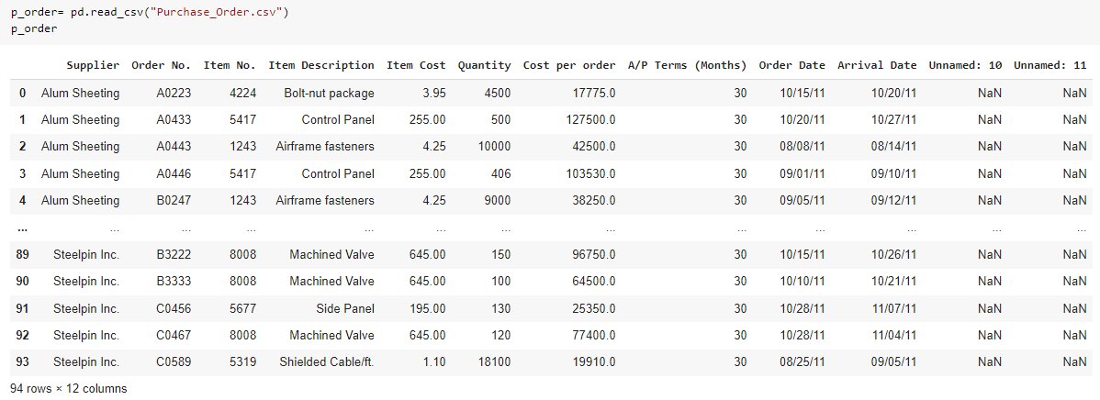

#### Meaning of values

Meaning of the values: Count, Min, Max, Mean, Median, Mode, Quantile, Range, Variance, Standard Deviation, Coefficient of Deviation, Skewness, Kurtosis.

Count:

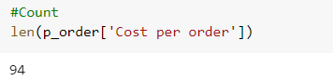

Min:

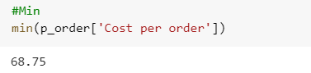

Max:

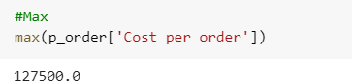

Mean:

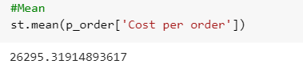

Median:

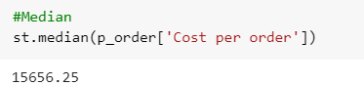

Mode:

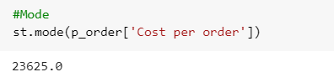

Quantile:

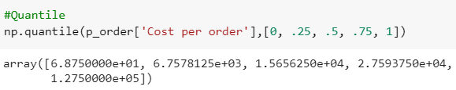

Range: 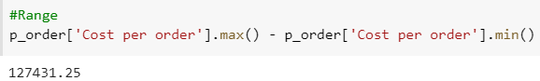

Variance:

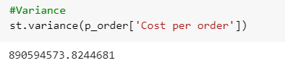

Standard Deviation:

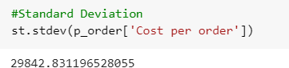

Coefficient of Deviation:

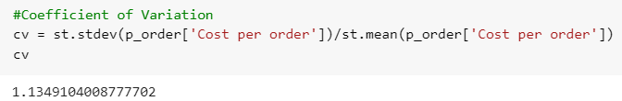

Skewness:

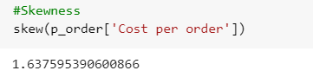

Kurtosis:

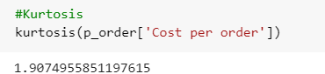

## Data Visualization

### Using MS Excel

#### Histogram

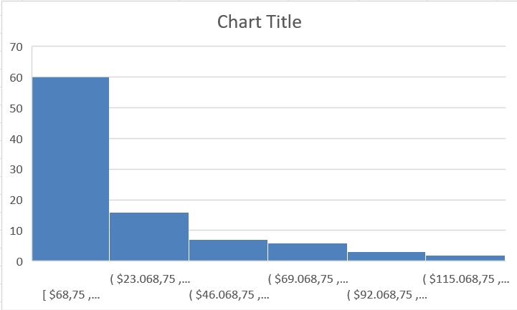

#### Box Plot

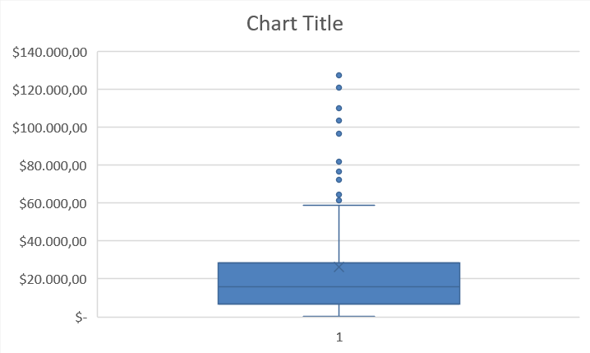

### Using R Programming Language

#### Histogram



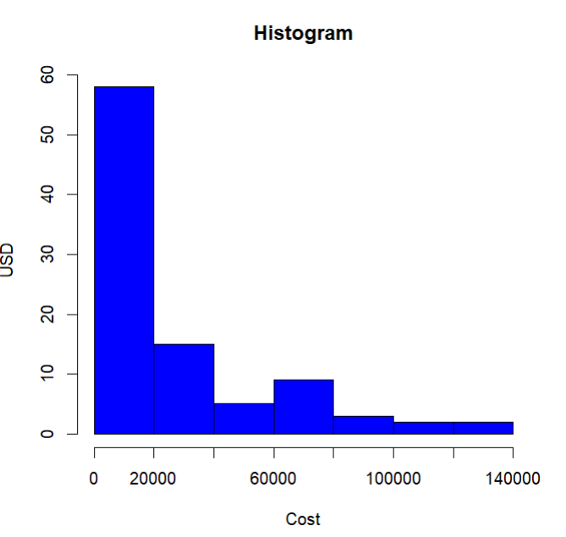

#### Box Plot



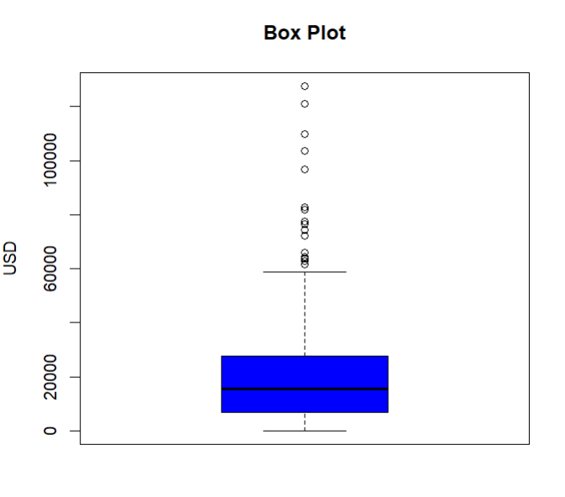

### Using Python Programming Language

#### Histogram

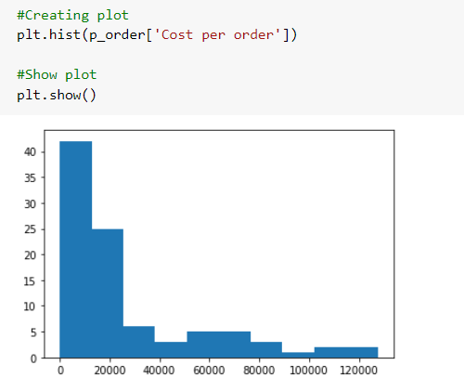

#### Box Plot

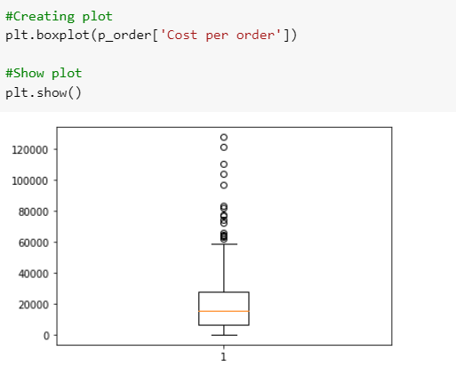

# Computer Repair Times

## Using MS Excel, R and Python Programming Language

### Using MS Excel

#### Statistical description

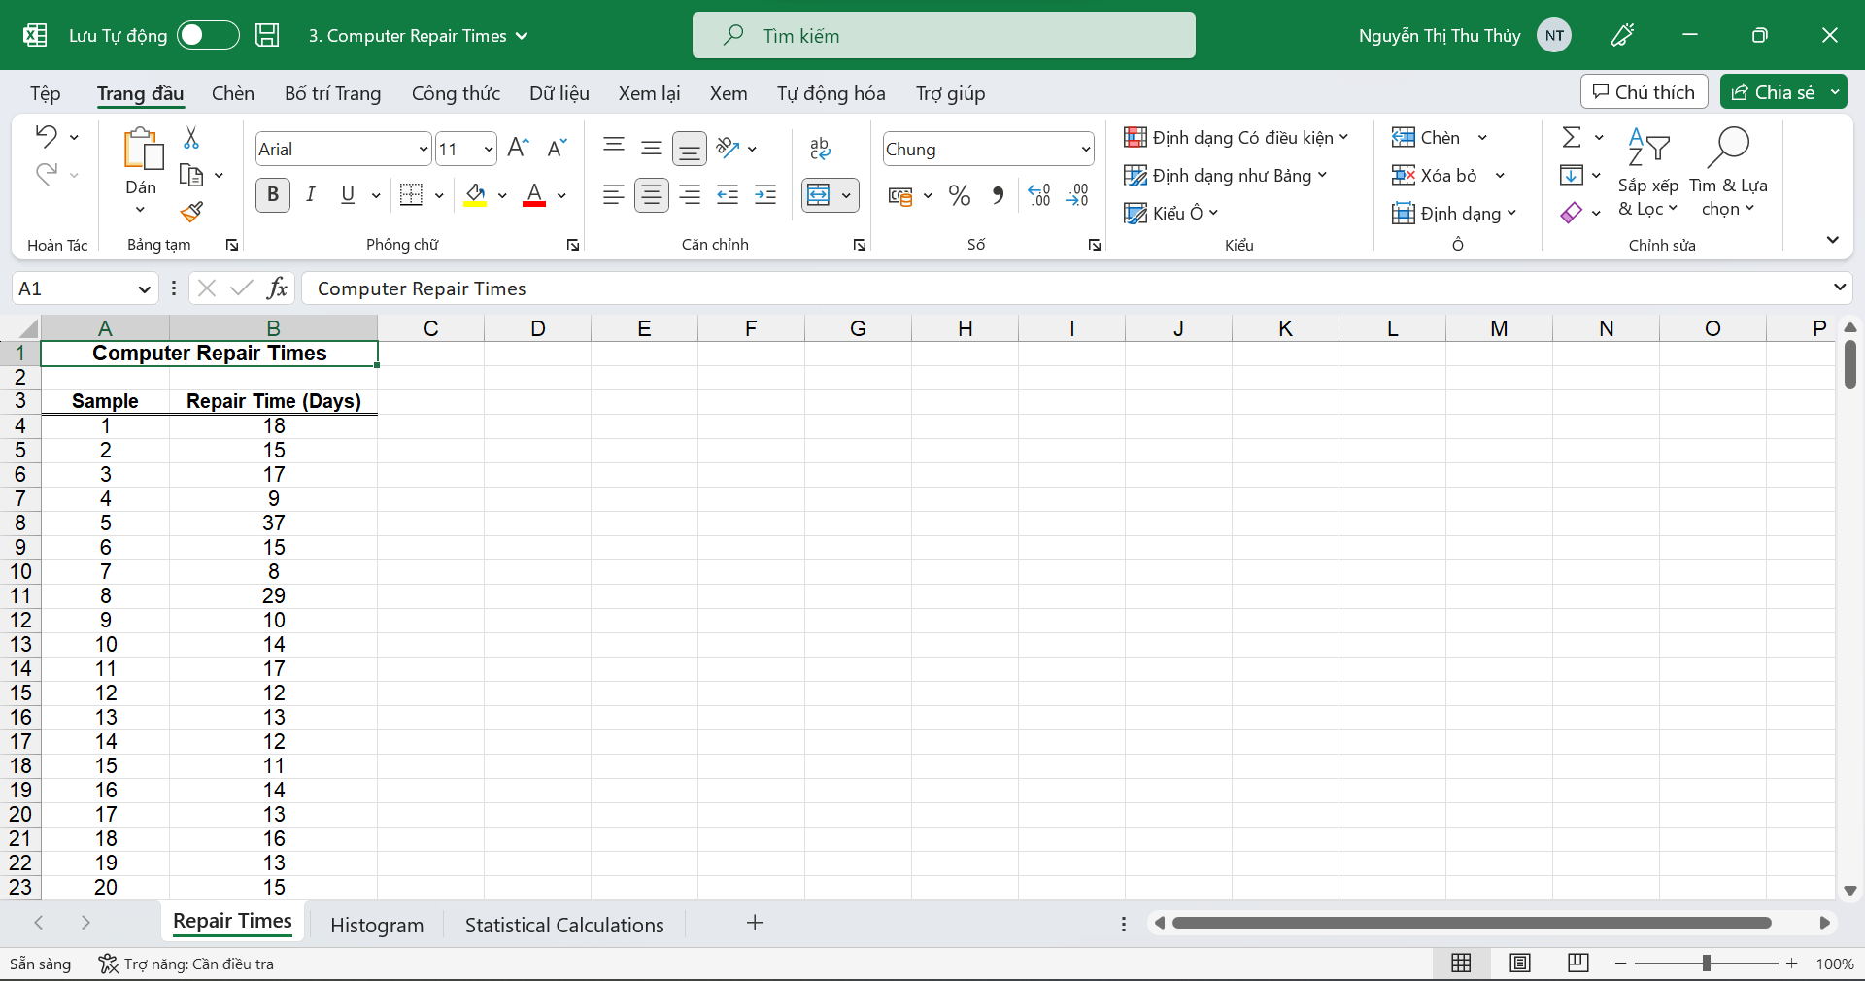

**Step 1:** Choose the “Dữ liệu” tab on the top of the Excel toolbar. Click the “Data Analysis” function. Click “Histogram,” and the “OK” button in the window pops up.

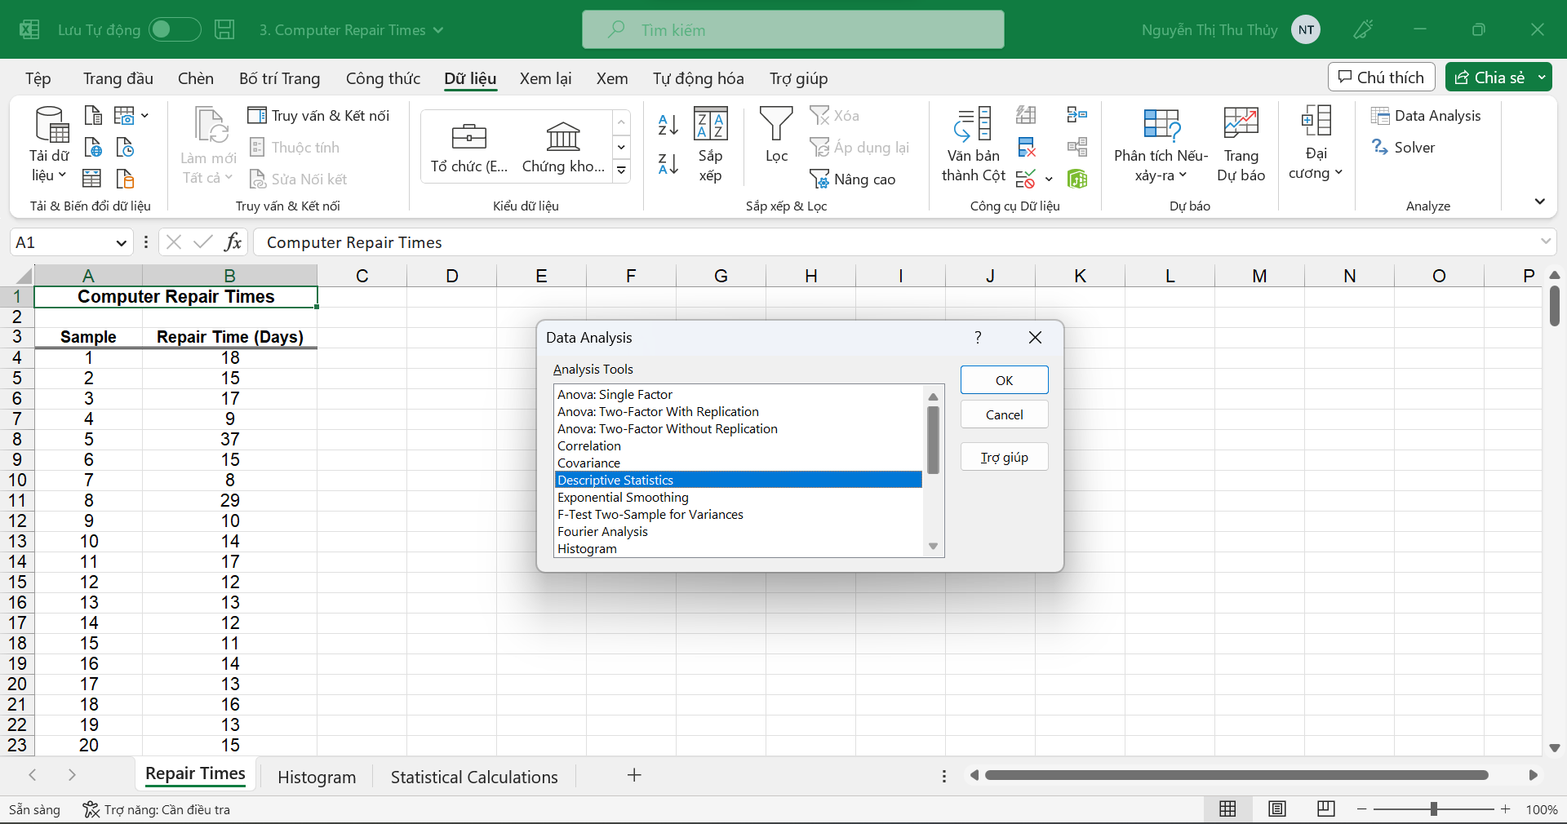

**Step 2:** Enter Input Range and select “Cumulative Percentage” for more specific information about the cumulative percentage and “Chart Output.”

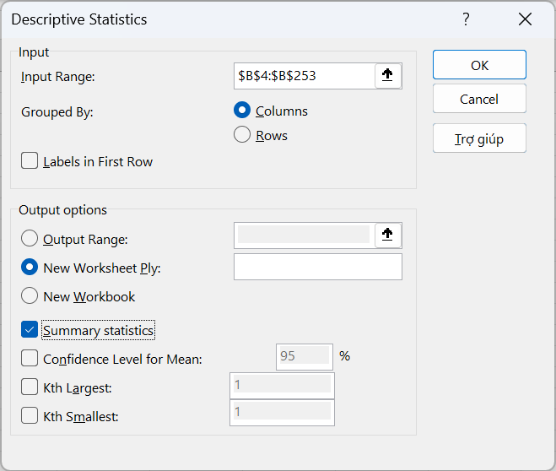

**Step 3:** Get the result

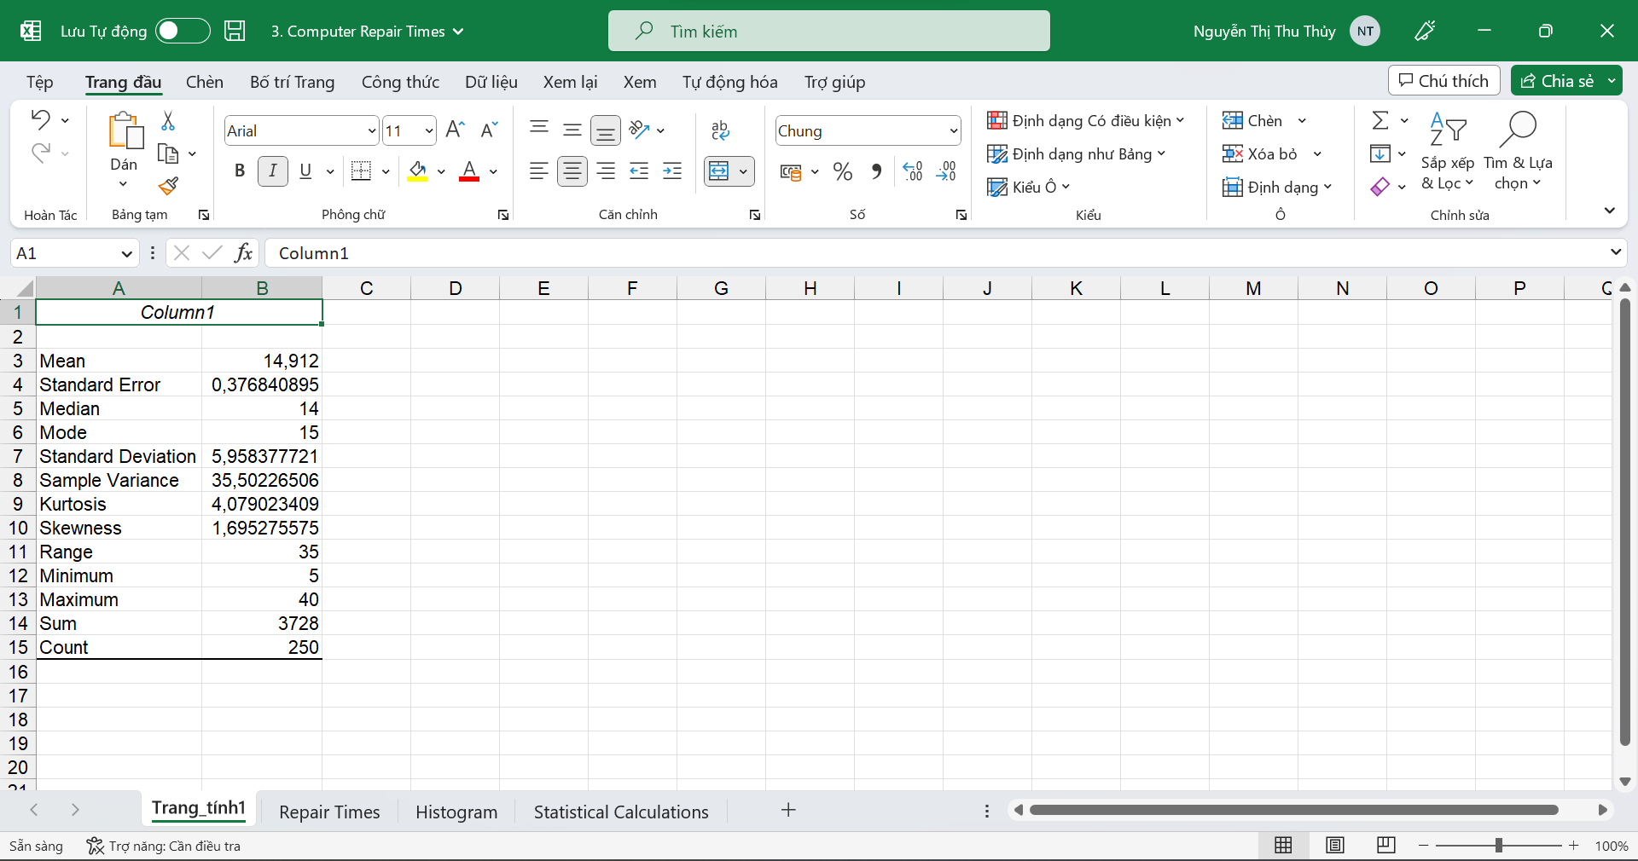

#### Meaning of values

Meaning of the values: Count, Min, Max, Mean, Median, Mode, Quantile, Range, Variance, Standard Deviation, Coefficient of Deviation, Skewness, Kurtosis.

**Count:** This counts the number of cells containing numeric data in a Data range (range) in all observations.

**Min:** The smallest value in your data set.

**Max:** The largest value in your data set.

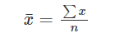**Mean:** The mean is the [average](https://www.statisticshowto.com/arithmetic-mean/)of a data set.

*(x = Observations given; n = Total number of observations)*

**Median:** The [median](https://www.statisticshowto.com/probability-and-statistics/statistics-definitions/mean-median-mode/" \l "median) is the middle number in a data set.

**Mode:** The mode is the data value that occurs most often in the dataset.

**Quantile:**

**Range:** The range of a list of numbers is just the difference between the largest and smallest values. It expresses spread, being how far the values are distributed (or how concentrated they are).

*Range = Highest - Smallest*

**Variance:** The [variance](https://www.cuemath.com/data/variance/) gives the variability of the distribution with respect to the mean.

**Standard Deviation:** The square root of the variance will result in the [standard deviation](https://www.cuemath.com/data/standard-deviation/). It helps to analyze the variability in a data set in a more effective manner as compared to the variance.

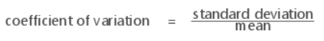**Coefficient of Deviation:** The coefficient of variation is a measure of relative variability calculated as a percentage.

**Skewness:** Skewness is a measure of asymmetry. A negative value indicates skewness to the left, and a positive value indicates skewness to the right. A zero value does not necessarily indicate symmetry.

**Kurtosis:** Kurtosis is one measure of how different a distribution is from the normal distribution. A positive value usually indicates that the distribution has a sharper peak than the normal distribution. A negative value indicates that the distribution has a flatter peak than the normal distribution.

#### Recalculation using Excel

**Count:**

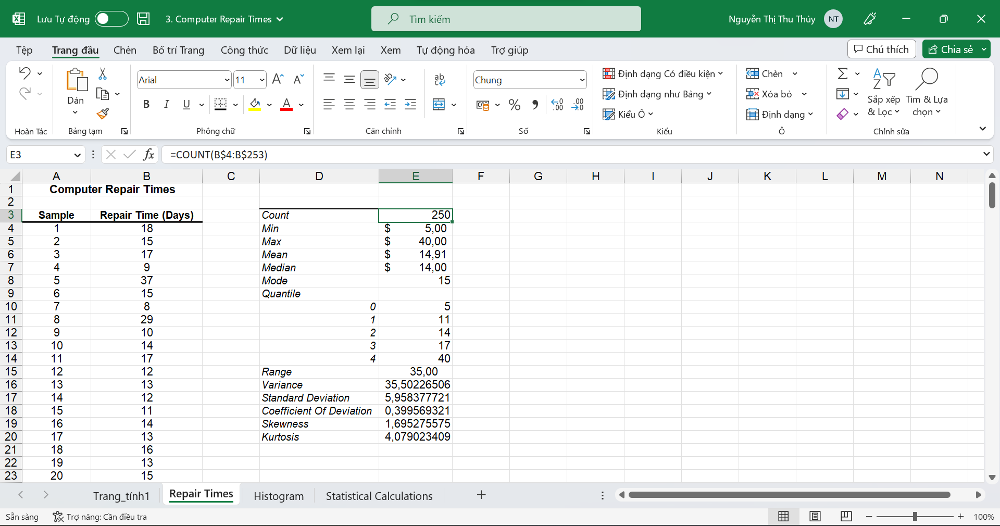

**Min:**

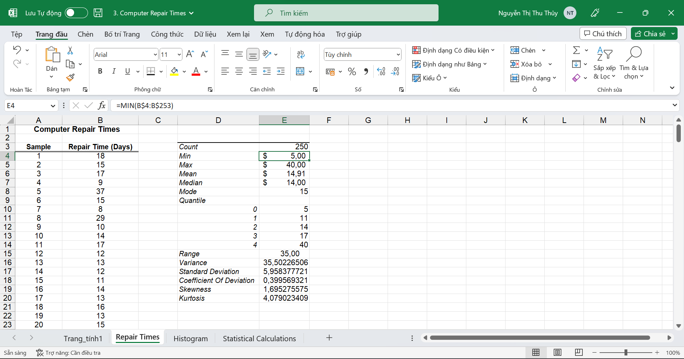

**Max:**

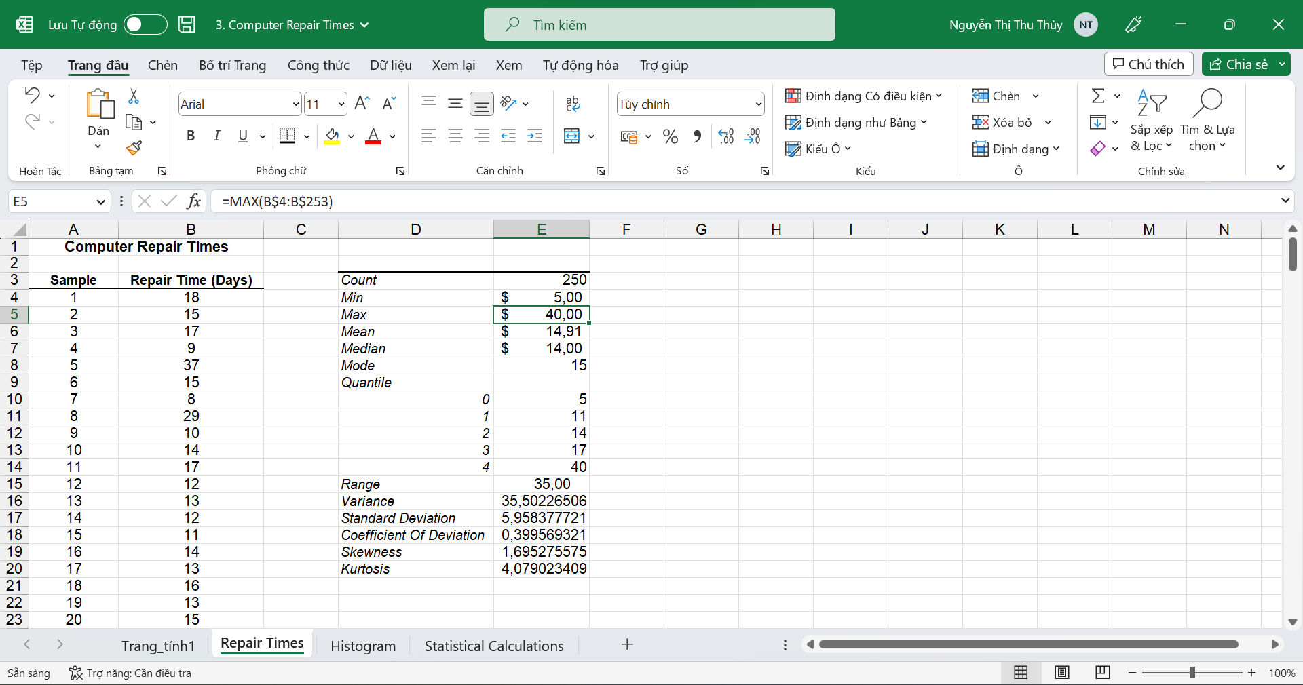

**Mean:**

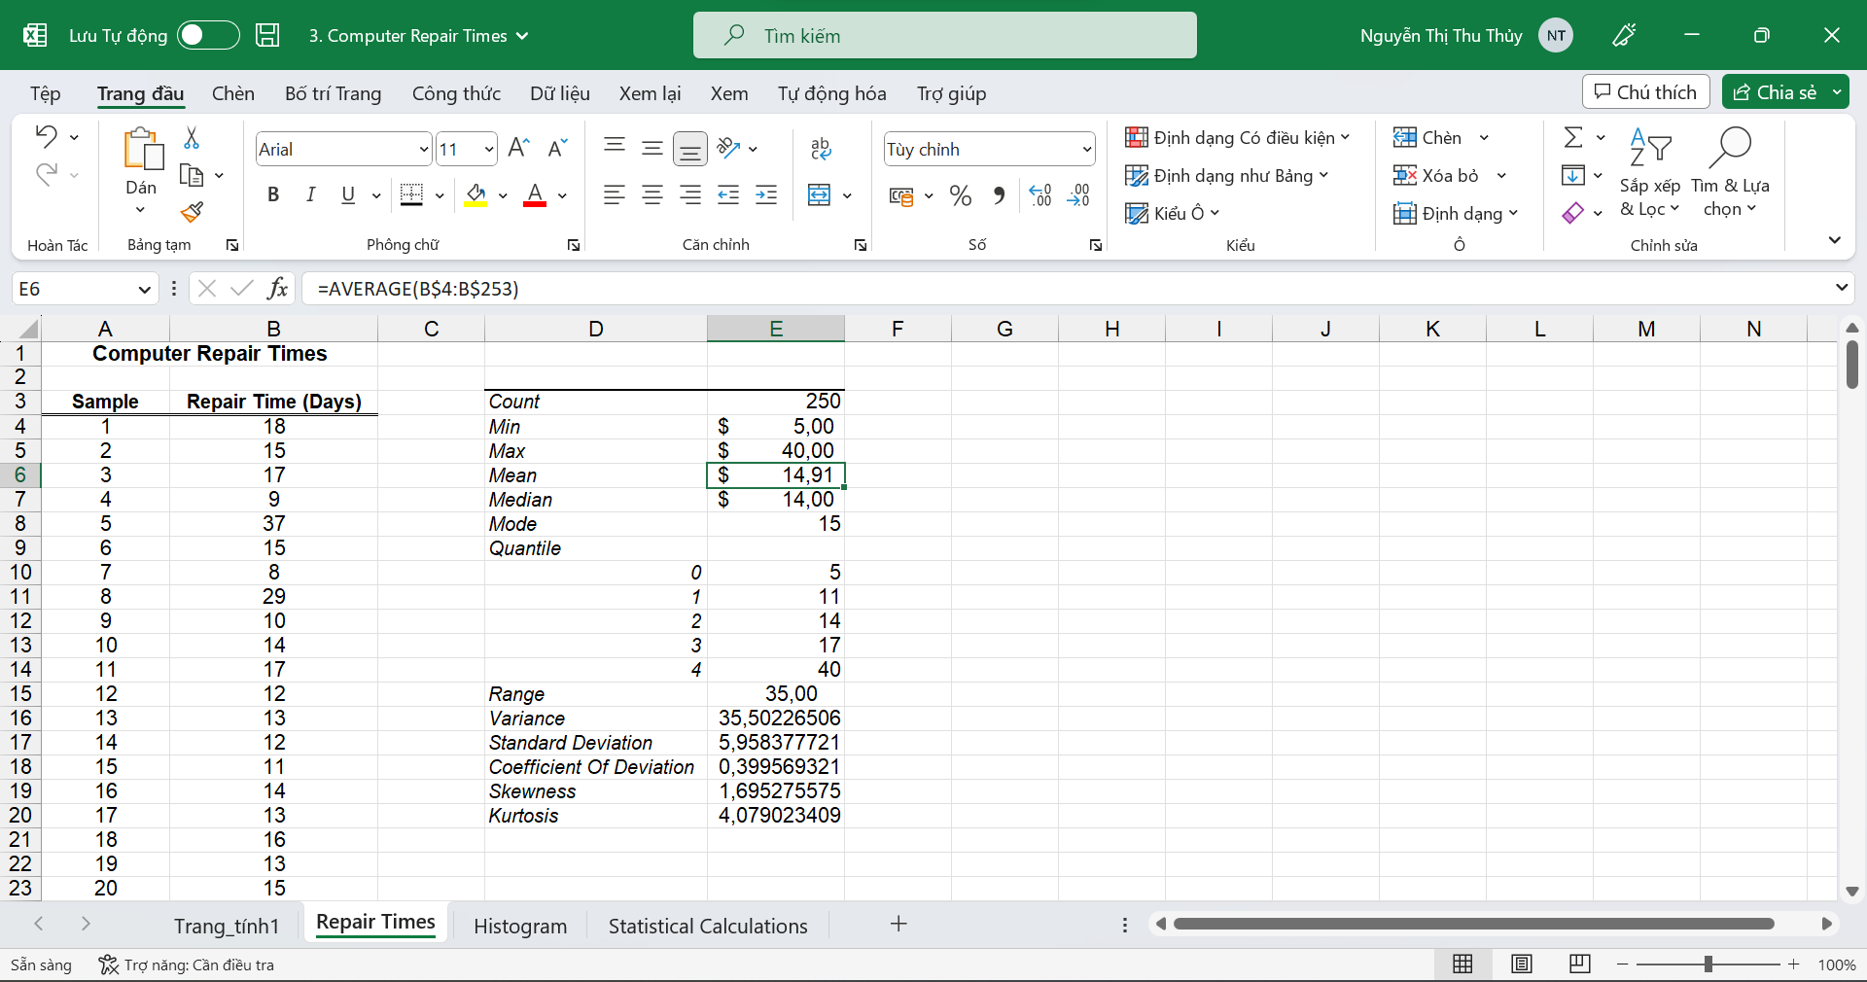

**Median:**

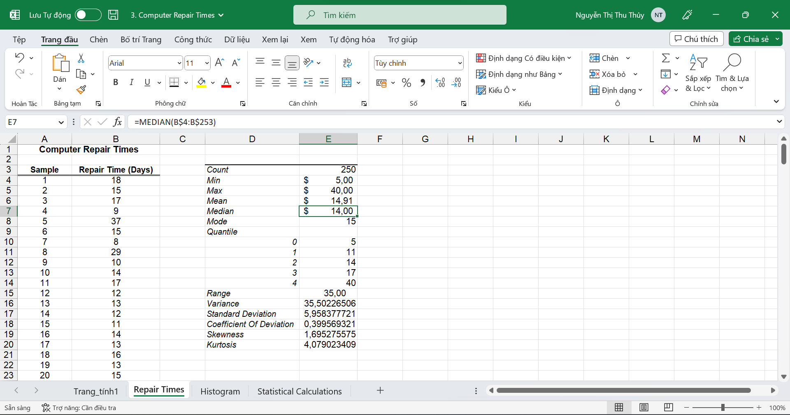

**Mode:**

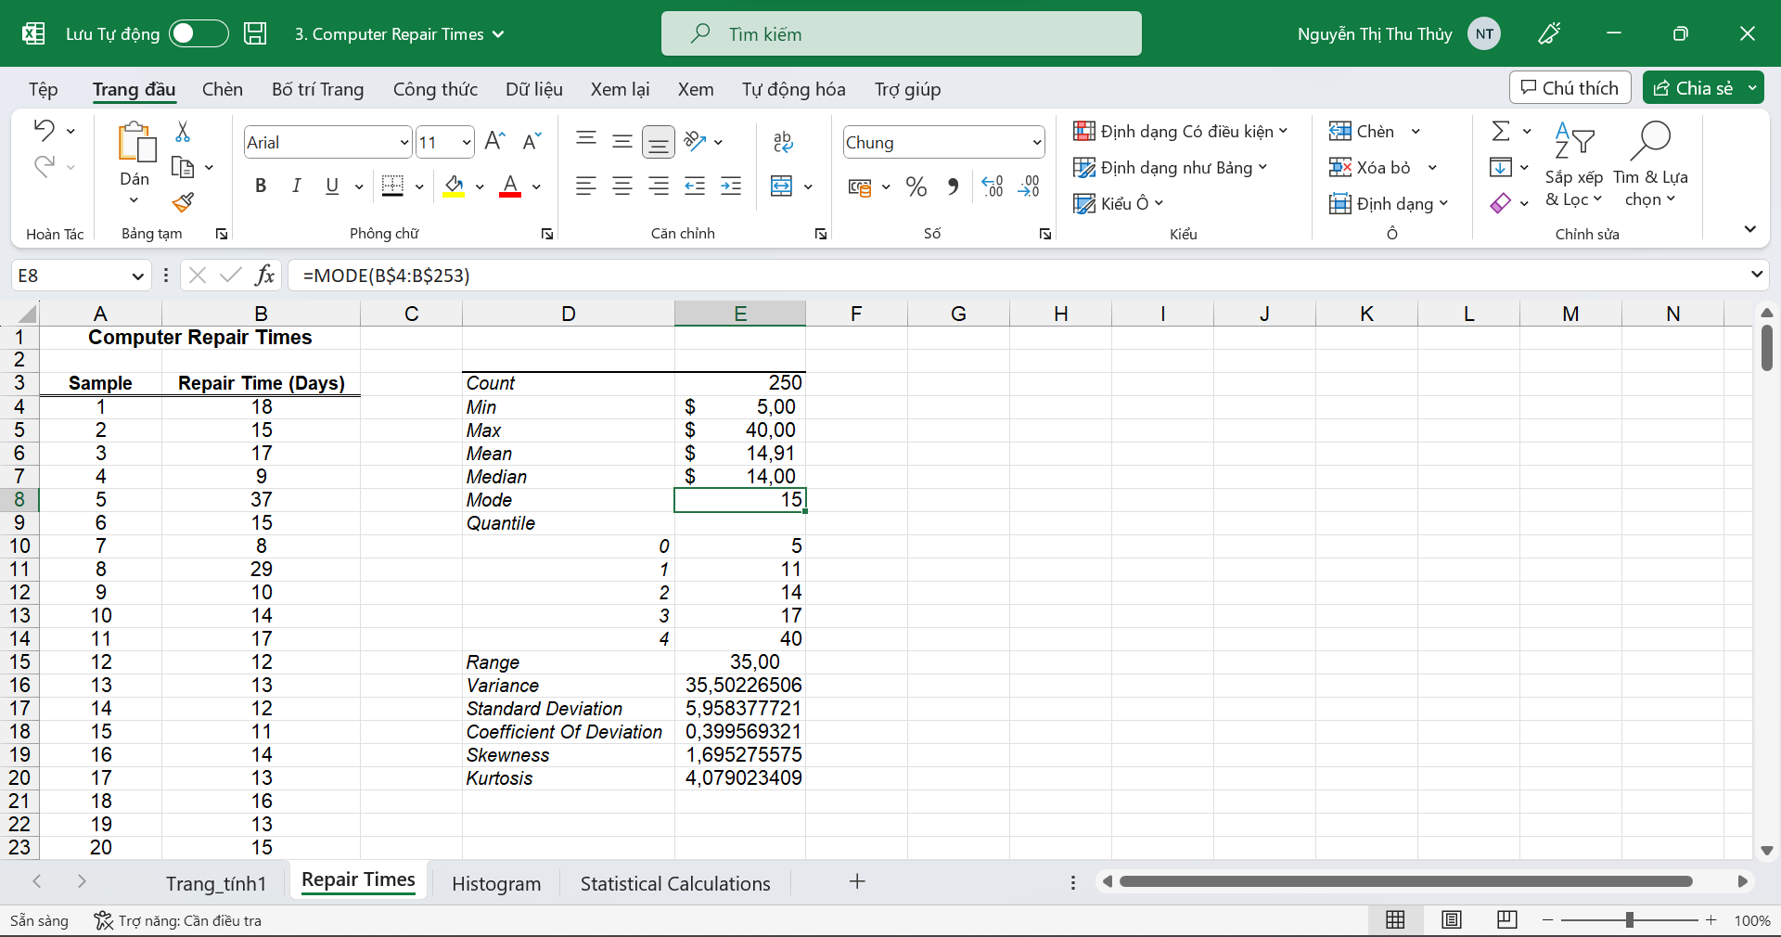

**Quantile:**

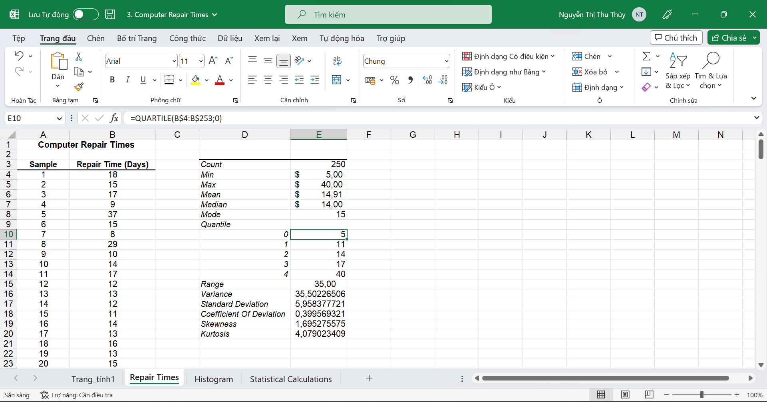

**Range:**

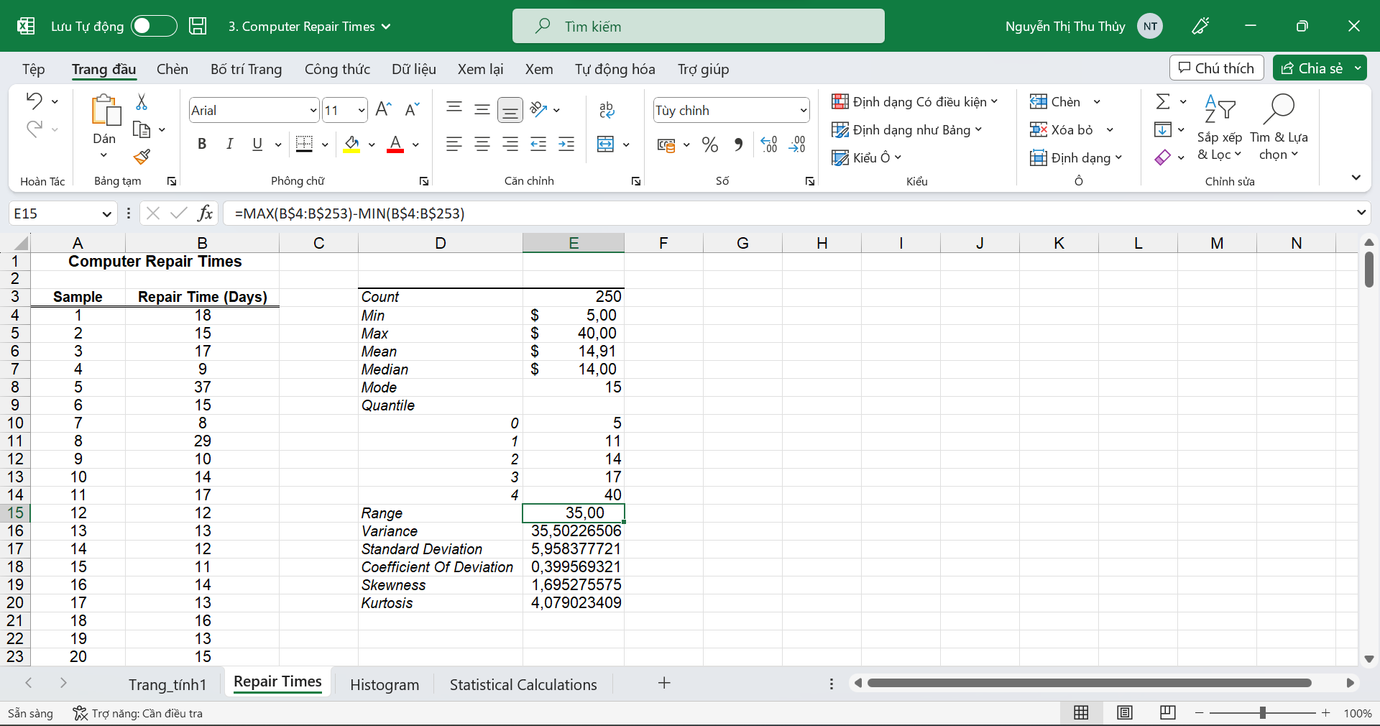

**Variance:**

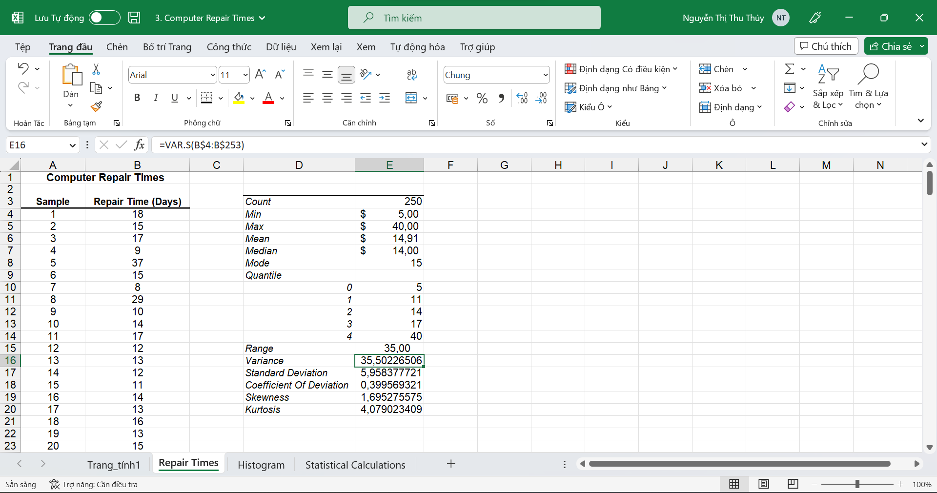

**Standard Deviation:**

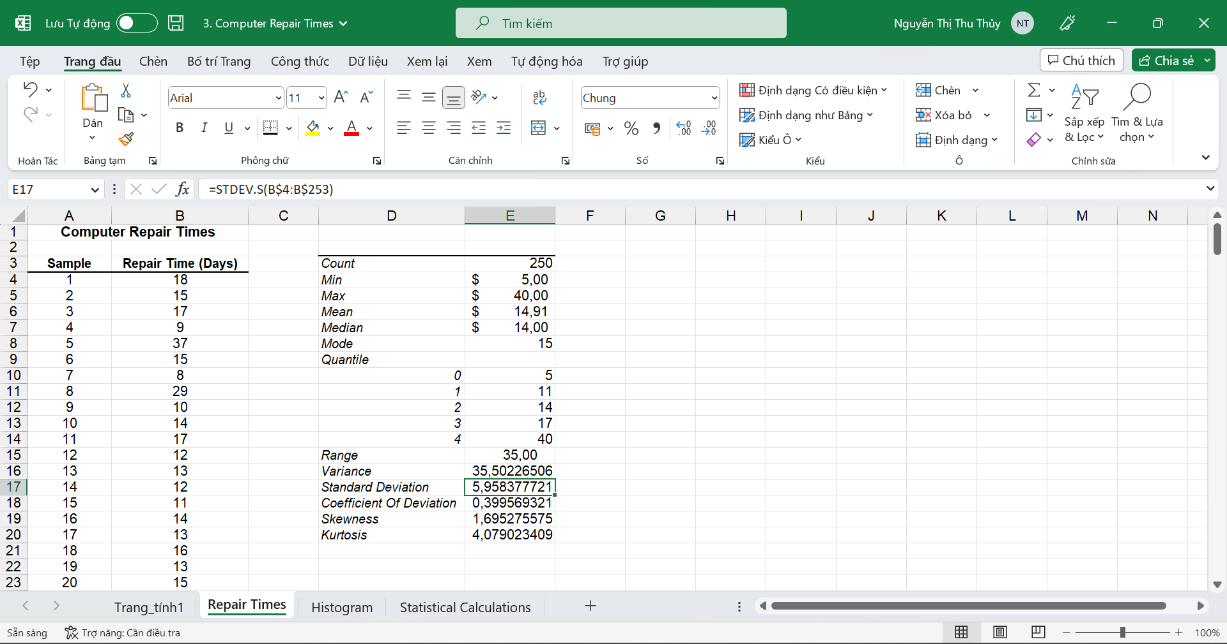

**Coefficient of Deviation:**

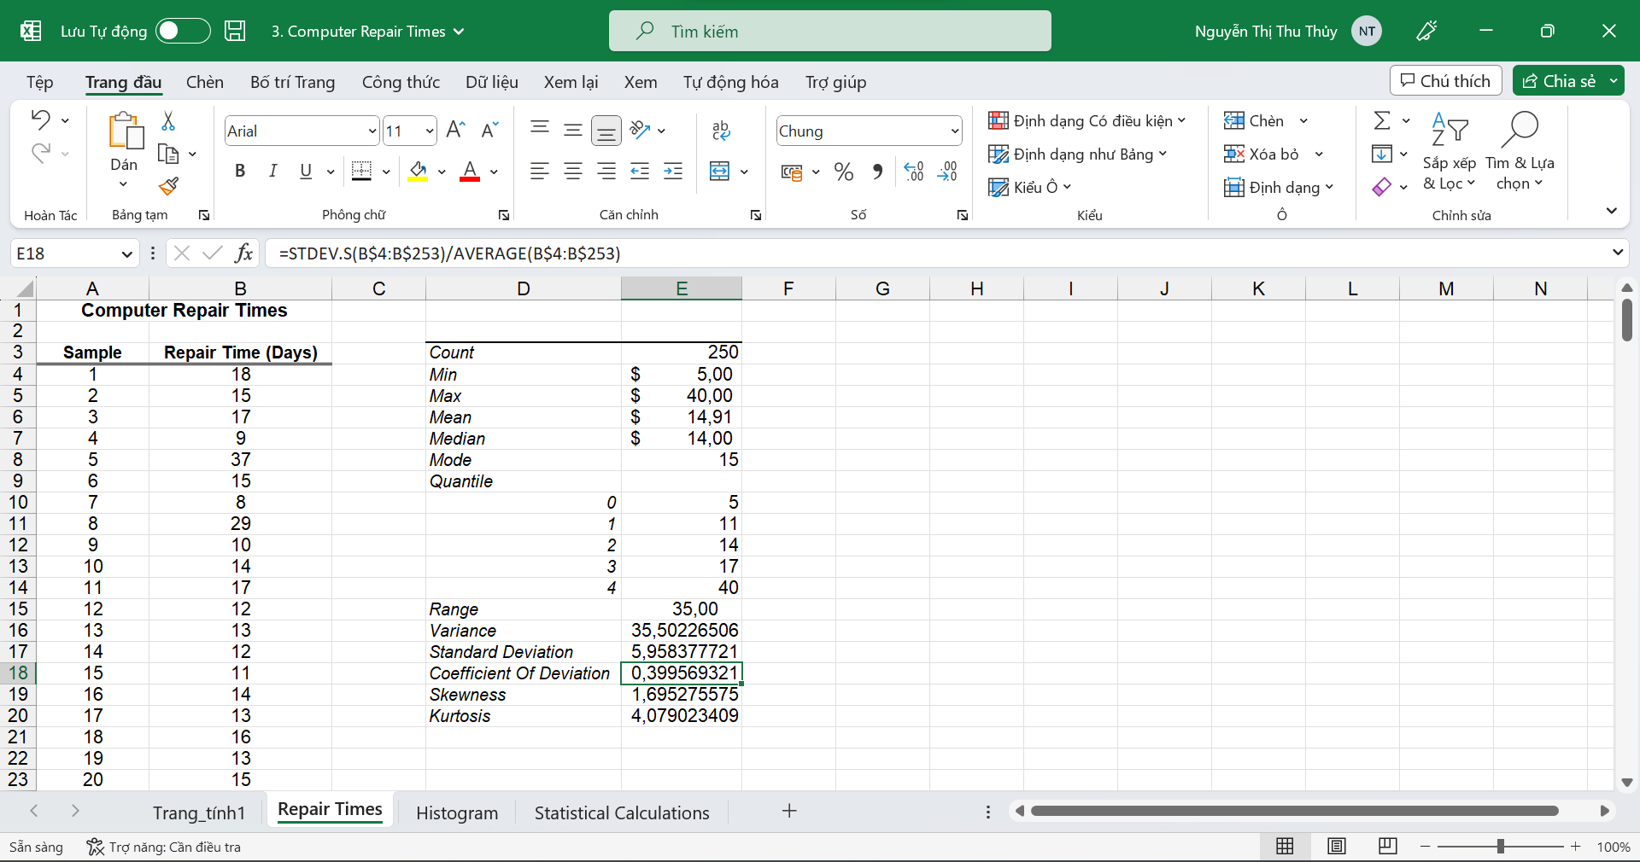

**Skewness:**

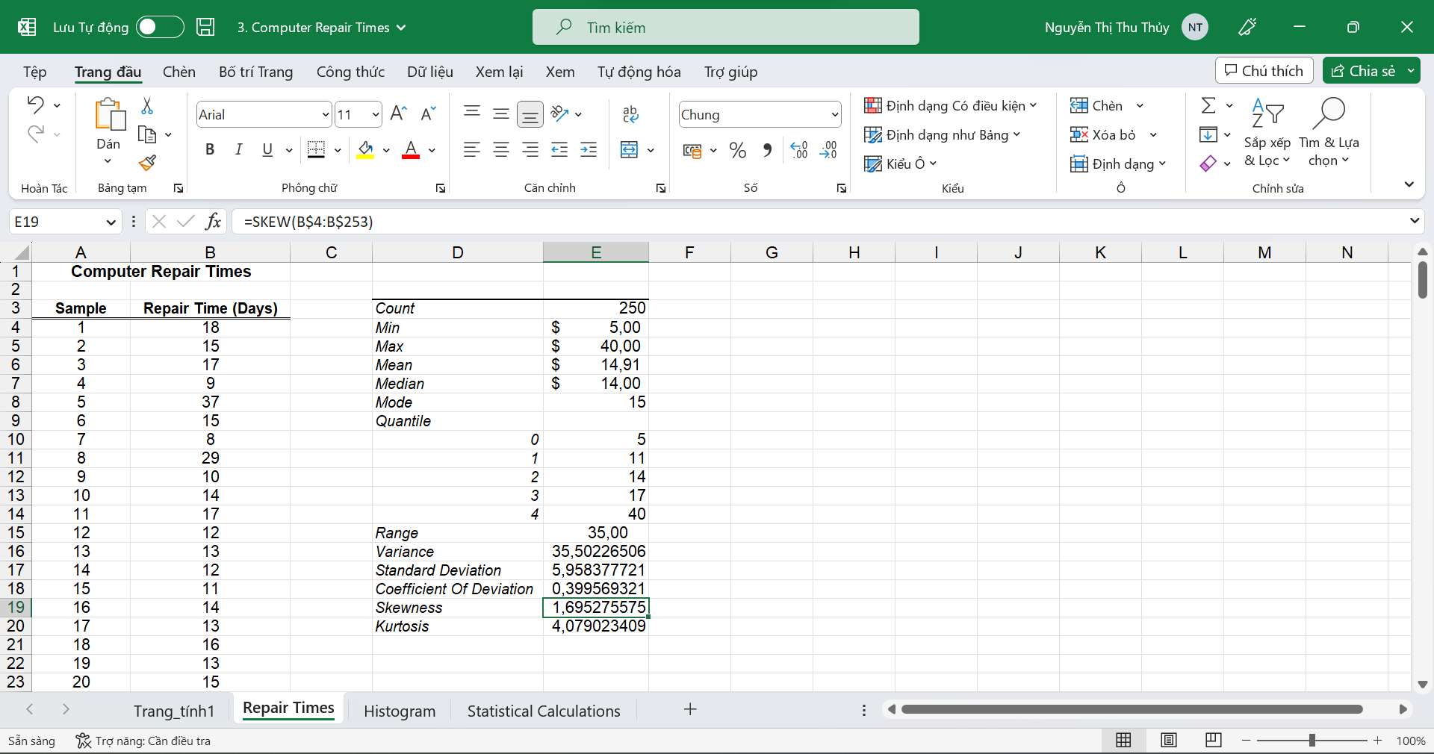

**Kurtosis:**

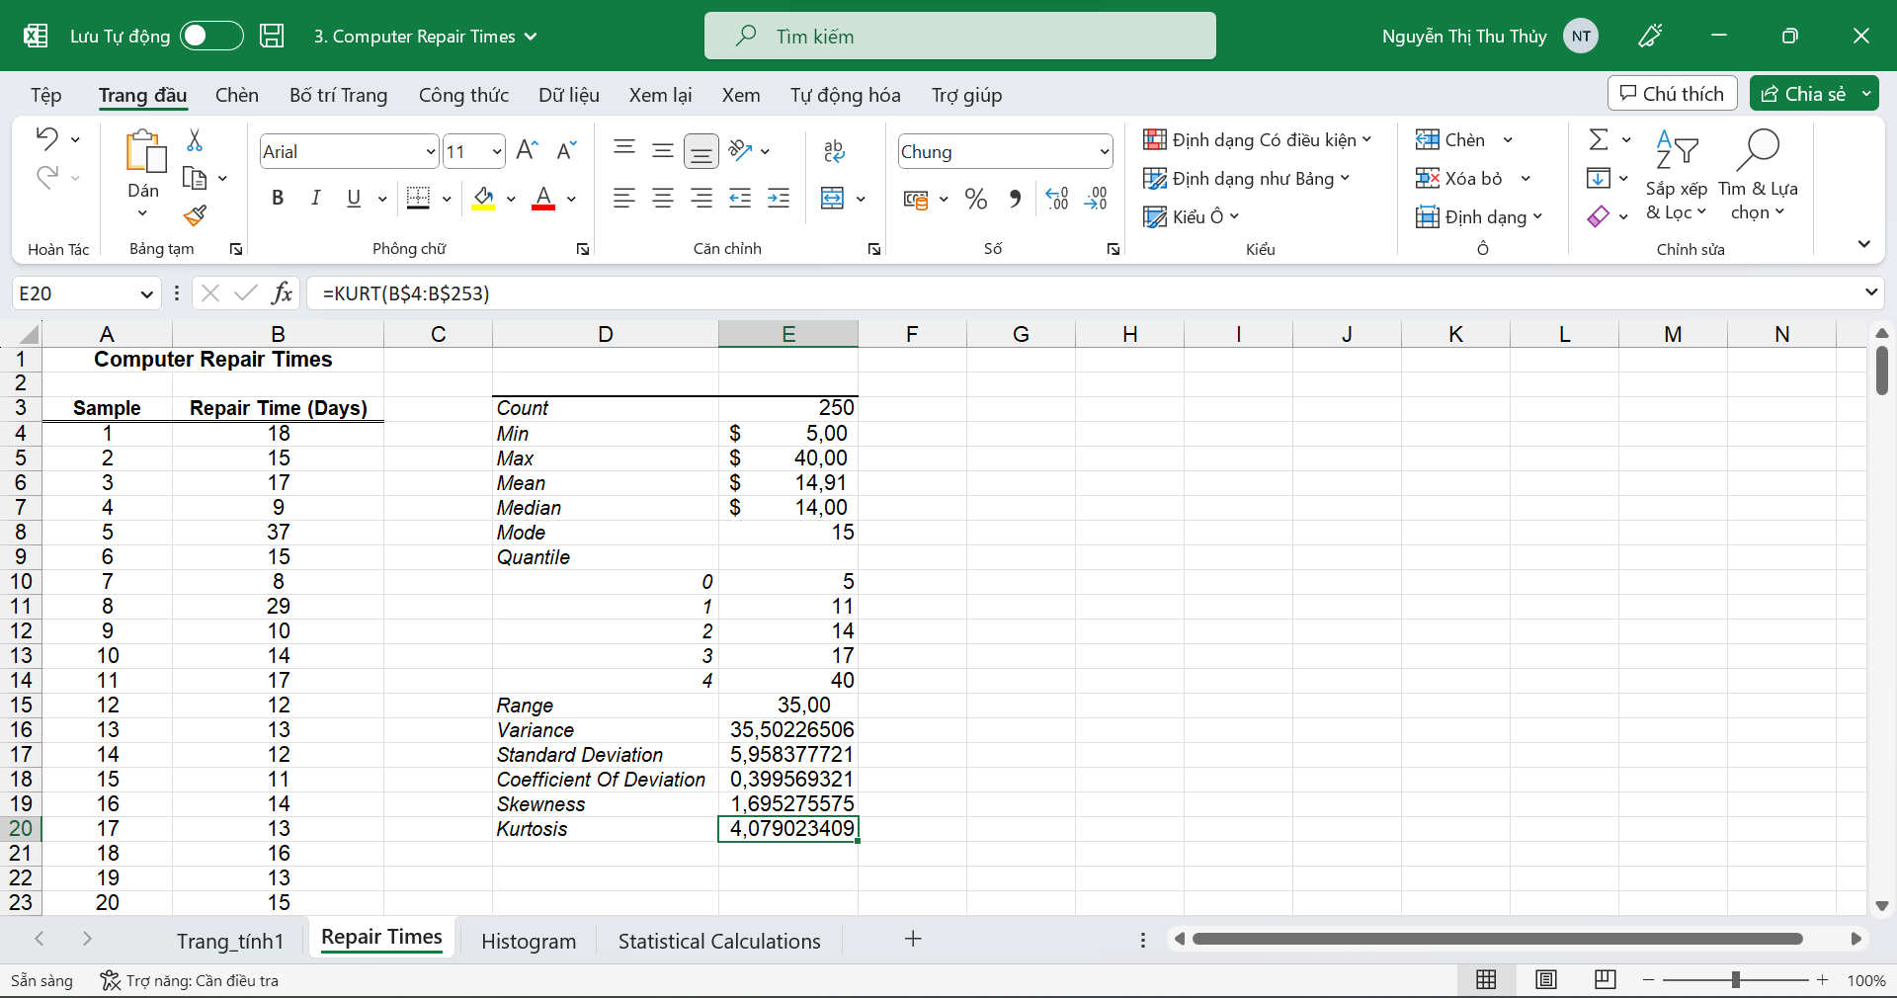

### Using R Programming Language

#### Statistical description

Import read dataset from excel file.

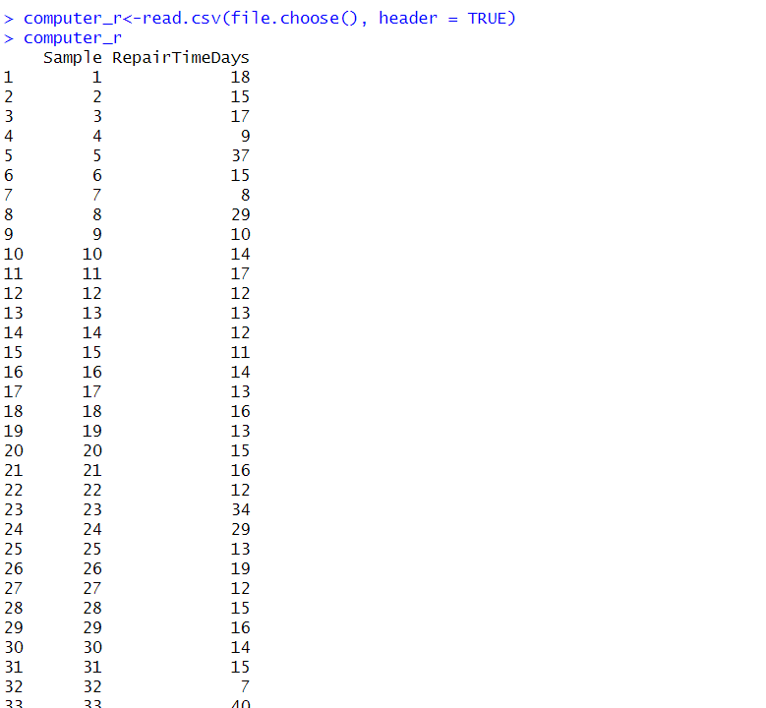

#### Meaning of values

Count:

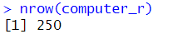

Min:

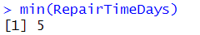

Max:

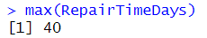

Mean:

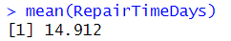

Median:

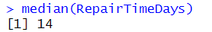

Mode:

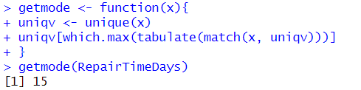

Quantile:

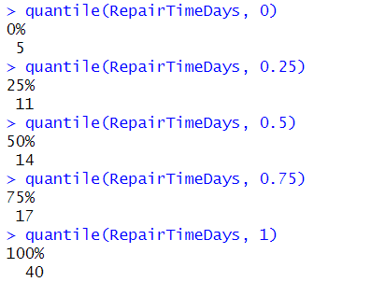

Range:

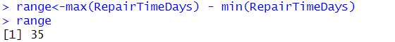

Variance:

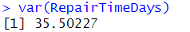

Standard Deviation:

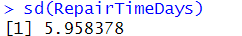

Coefficient of Deviation:

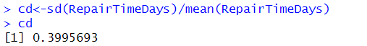

Skewness:

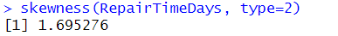

Kurtosis:

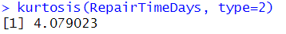

### Using Python Programming Language

#### Statistical description

Import libraries and read dataset from excel file.



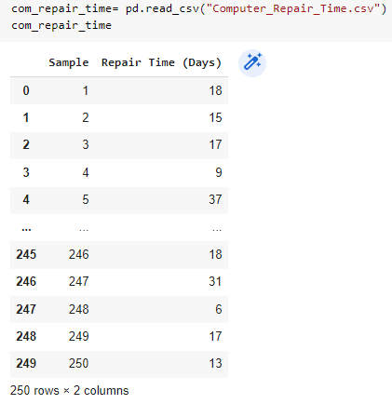

#### Meaning of values

Meaning of the values: Count, Min, Max, Mean, Median, Mode, Quantile, Range, Variance, Standard Deviation, Coefficient of Deviation, Skewness, Kurtosis.

Count:

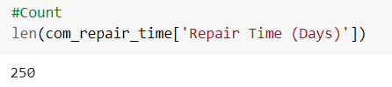

Min:

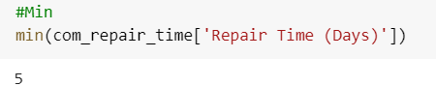

Max:

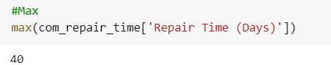

Mean:

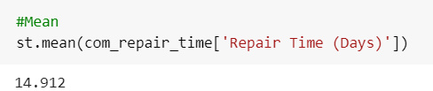

Median:

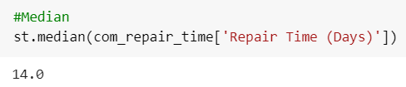

Mode:

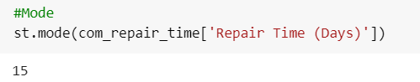

Quantile:

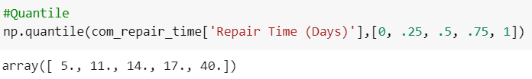

Range:

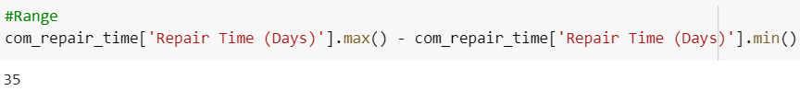

Variance:

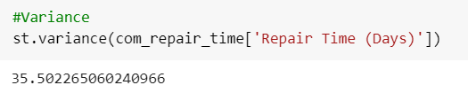

Standard Deviation:

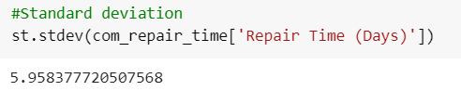

Coefficient of Deviation:

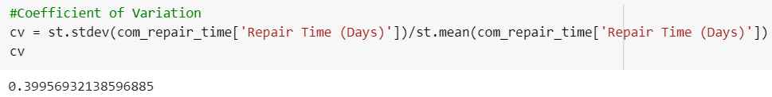

Skewness:

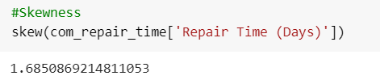

Kurtosis:

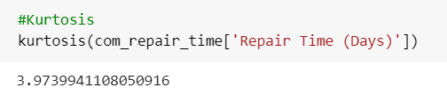

## Data Visualization

### Using MS Excel

#### Histogram

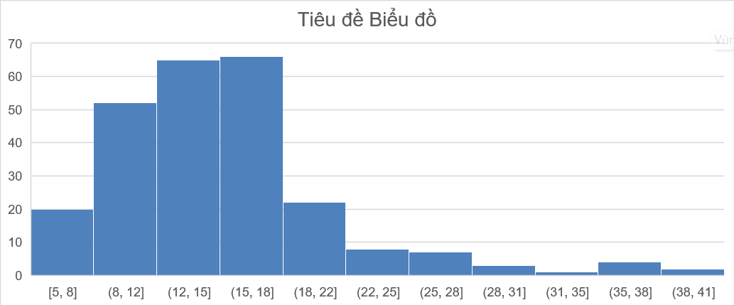

#### Box Plot

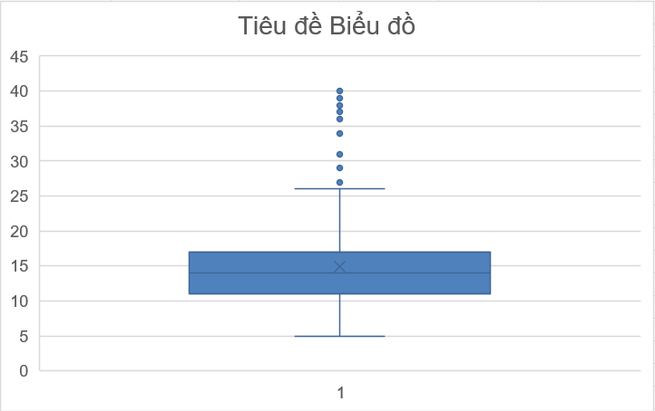

### Using R Programming Language

#### Histogram



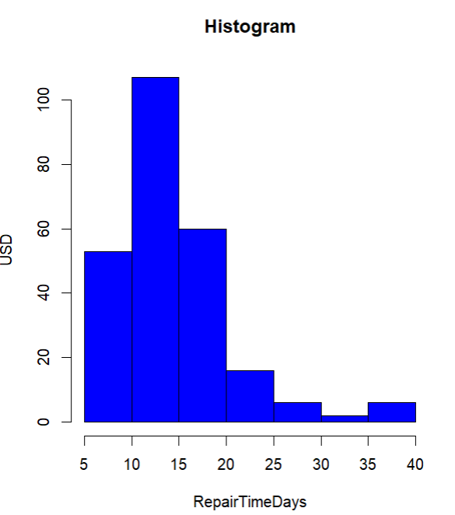

#### Box Plot



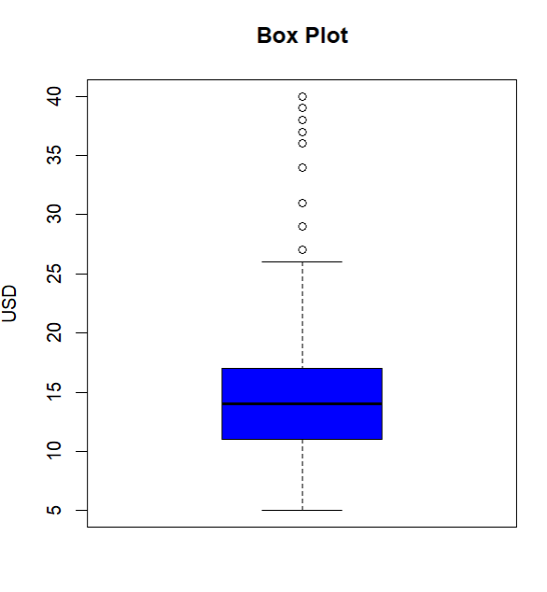

### Using Python Programming Language

#### Histogram

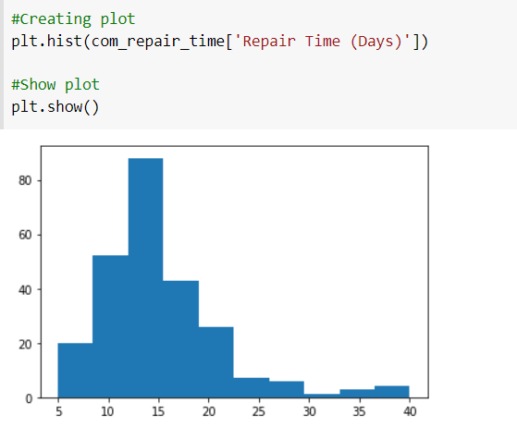

#### Box Plot

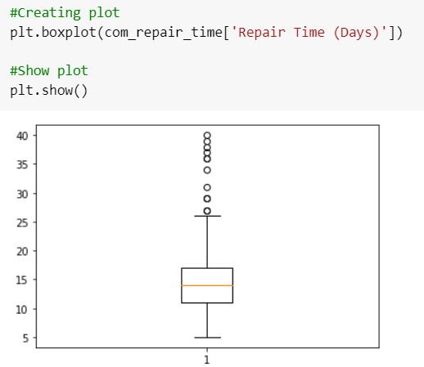

# REFERENCES

[1] Kanchan_Ray, “Get the number of rows of an Object in R Programming – nrow() Function”, 09 Mar 2021. [Get the number of rows of an Object in R Programming – nrow() Function](https://www.geeksforgeeks.org/get-the-number-of-rows-of-an-object-in-r-programming-nrow-function/) (accessed Mar. 14,2023)

[2] “Tutorials Point”. [R - Mean, Median and Mode](https://www.tutorialspoint.com/r/r_mean_median_mode.htm) (accessed Mar. 14,2023)

[3] "Excel help & learning," Support, https://support.microsoft.com/en-us/excel

[4] Adam Hayes, “What Is Variance in Statistics? Definition, Formula, and Example”, Mar. 14, 2023, [What Is Variance in Statistics? Definition, Formula, and Example (investopedia.com)](https://www.investopedia.com/terms/v/variance.asp) (accessed Mar. 15,2023)

[5] “Methods and formulas for Display Descriptive Statistics”, [Methods and formulas for Display Descriptive Statistics - Minitab](https://support.minitab.com/en-us/minitab/20/help-and-how-to/statistics/basic-statistics/how-to/display-descriptive-statistics/methods-and-formulas/methods-and-formulas/) (accessed Mar. 13,2023)

[6] “Mean Median Mode: What They Are, How to Find Them”, [Mean Median Mode: What They Are, How to Find Them - Statistics How To](https://www.statisticshowto.com/probability-and-statistics/statistics-definitions/mean-median-mode/) (accessed Mar. 13,2023)

[7] “Descriptive Statistics”, [Descriptive Statistics - Examples, Types, Definition, Formulas (cuemath.com)](https://www.cuemath.com/data/descriptive-statistics/) (accessed Mar. 15,2023)

[8] “Mean, Median, Mode, and Range”, [Mean, median, and mode: they're *all* averages..? | Purplemath](https://www.purplemath.com/modules/meanmode.htm) (accessed Mar. 14, 2023)